Giants Visual Guide
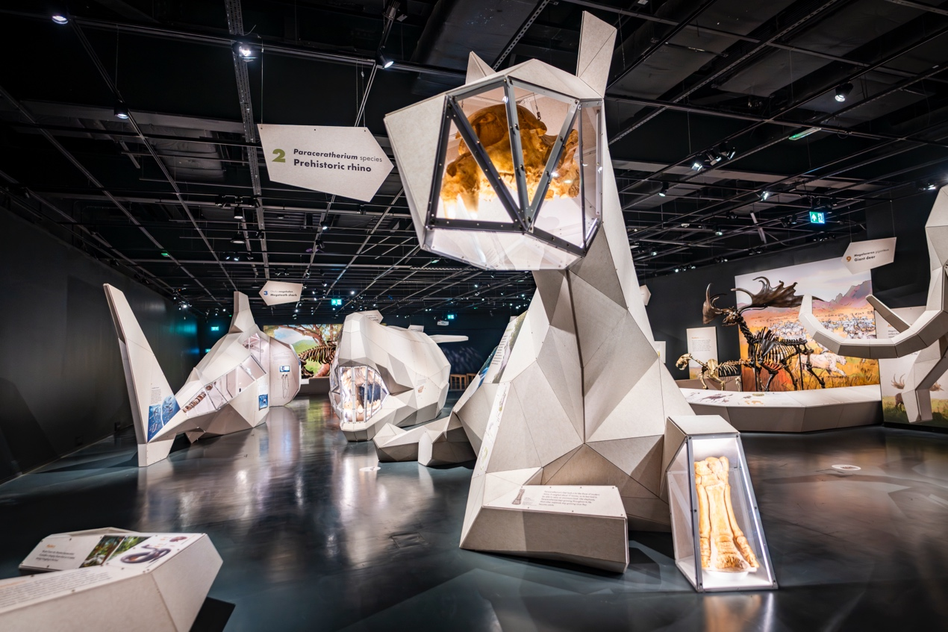
31 January to 14 September 2026
National Museum of Scotland
Chambers Street
Edinburgh
EH1 1JF
This visual guide is designed to support a visit to the exhibition Giants at the National Museum of Scotland.

Contents
Visiting the National Museum of Scotland 3
Tickets 3
Visiting the exhibition 5
General information 5
Notes on the exhibition 5
Relaxed Views of Giants 7
Getting to the exhibition 8
Toilets 9
Exhibition Sensory Map 9
A visual walk through the exhibition 10
Exhibition exit and shop 21
Contact us 22

Visiting the National Museum of Scotland
There are two entrances to the National Museum of Scotland.
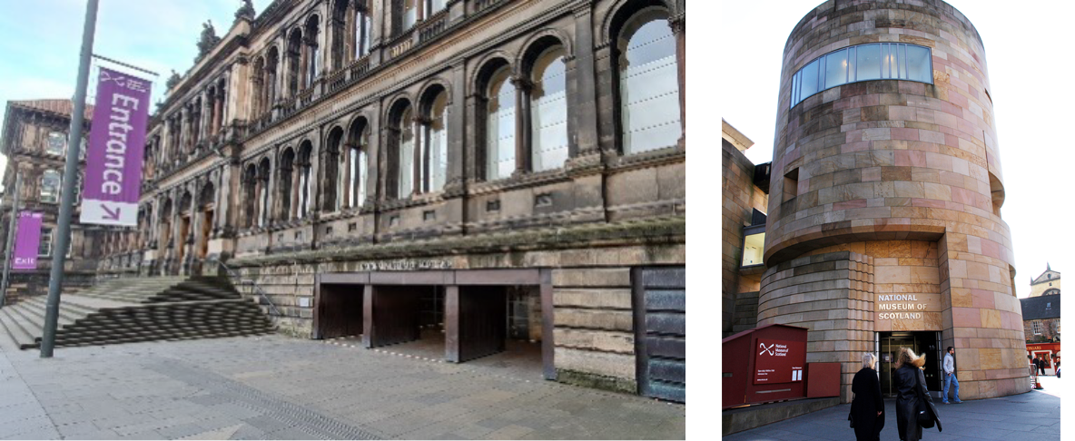
The Main Entrance and the Tower Entrance
The Tower Entrance is usually quieter and offers step-free access to the museum.
Please visit our ‘Plan Your Visit’ webpage for more information about getting to the museum, facilities, and accessible parking. You can also download a map of the museum.
Guide dogs and assistance animals are welcome in all areas of the museum.
General visual stories are available to support your visit:
Main entrance visual story
Tower Entrance visual story
To find out more about accessibility at the museum please visit our Accessibility webpage.

Tickets
A general visit to the museum is free and no booking is required. However, to visit the Giants exhibition you will need to book a ticket. Tickets can be booked online (click to visit the booking page) or booked at either the Main Entrance Information Desk on Level 0 or the Exhibition Ticket Desk on Level 3, subject to availability. Tickets are cheaper when purchased in advance of your visit (up to 24 hours before visiting). We recommend booking in advance to avoid disappointment.
If you need any help with booking tickets, please call 0300 123 6789 (10:00-17:00).
To find out about ticket pricing visit our website: www.nms.ac.uk/giants
When you arrive at the museum, there are information desks at both entrances. If you would like to pick up a map or if you have any questions, our Visitor Experience staff can help you.
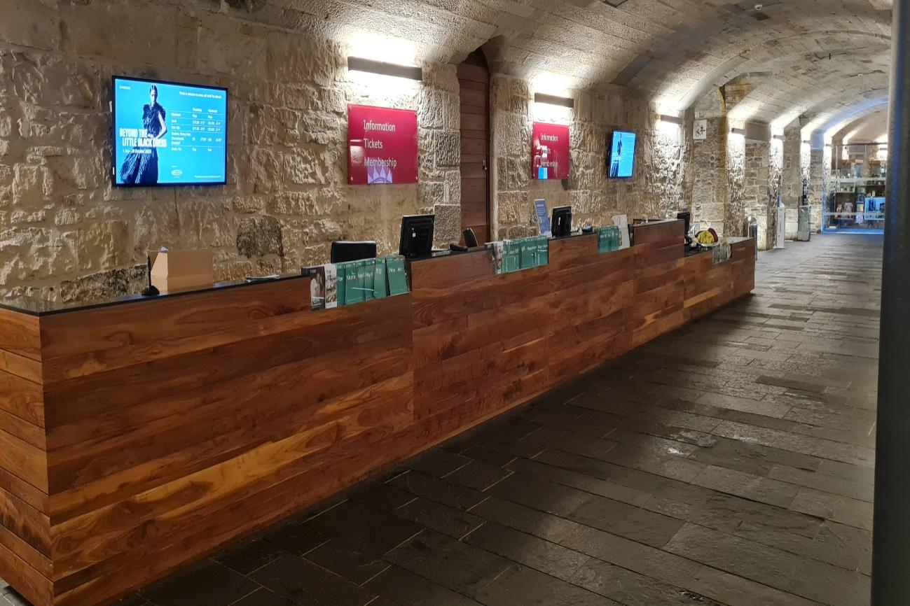
Our Visitor Experience staff wear purple shirts and lanyards and are situated throughout the museum.
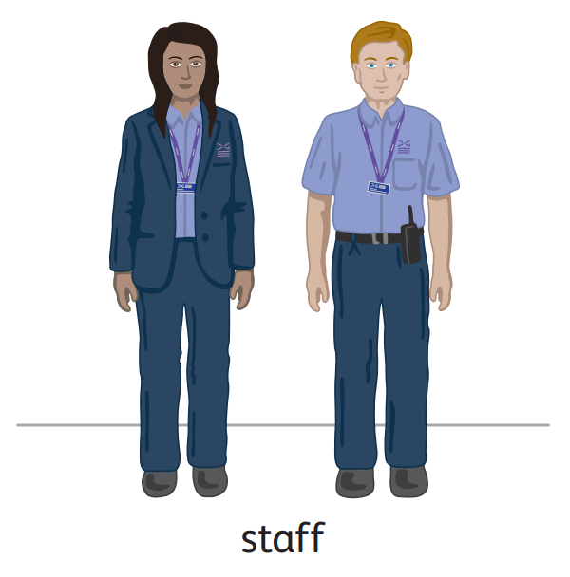
A limited number of sensory maps of the museum and sensory backpacks are available to borrow for free from the information desks.

Visiting the exhibition

General information
Giants showcases the colossal prehistoric creatures that lived after the extinction of the dinosaurs, 66 million years ago.
Discover life-sized 3D sculptures, skeletons, and fossils in this immersive, family friendly exhibition. Find out about Otodus megalodon, the largest shark to have ever swum the oceans, and Titanoboa cerrejonensis, the biggest ever snake. Visitors to Giants will immerse themselves in the world of a palaeontologist. Use interactives to learn how fossils have been discovered and find out how prehistoric giants have been reconstructed.
The Giants exhibition is designed and produced by the Royal Belgian Institute of Natural Sciences.

Notes on the exhibition
- Personal photography is encouraged but flash is not allowed.
- No eating or drinking in the exhibition.
- Giants is a very interactive and sensory exhibition with videos including lights, colour changes and sounds.
- There is a soundtrack featuring animal sounds which can be heard throughout the exhibition. This will be turned off during Relaxed Views.
- Lighting levels vary around the exhibition but are generally quite low.
- Some of the films depict scenes of animals hunting – these are marked as content warnings on the sensory map.
- There are wooden benches available in the exhibition. Portable foldable stools are also available at the exhibition entrance.
- Large print guides are available in a holder through the entrance door to the left as you go in.
- Some of the films in the exhibition feature audio in French, Dutch and Spanish.
- All videos have closed captions in English.
- Child and adult ear defenders are available to borrow from the Exhibition Desk.
- For more information about the accessibility of the exhibition please visit the exhibition website.

Relaxed Views of Giants
- Sunday 1 March, 10:00-12:00
- Thursday 16 April, 10:00-12:00
- Sunday 3 May, 10:00-12:00
- Sunday 7 June, 10:00-12:00
- Sunday 5 July, 10:00-12:00
- Sunday 2 August, 10:00-12:00
- Sunday 6 September, 10:00-12:00
Last entry to Relaxed Views is at 11:00.
During Relaxed Views visitor numbers are limited and, where possible, sounds are reduced or turned off.

Getting to the exhibition
Giants is in Special Exhibition Gallery 1 on Level 3 of the museum. Level 3 is accessible via a lift, an escalator, or stairs.
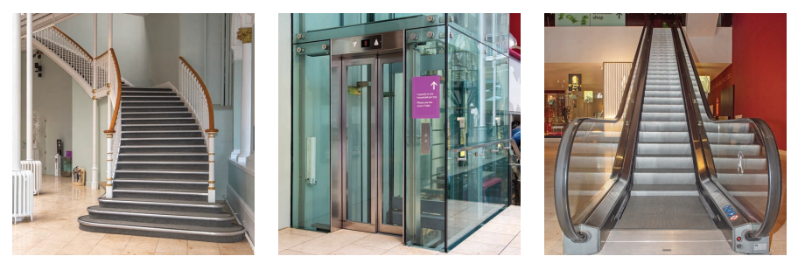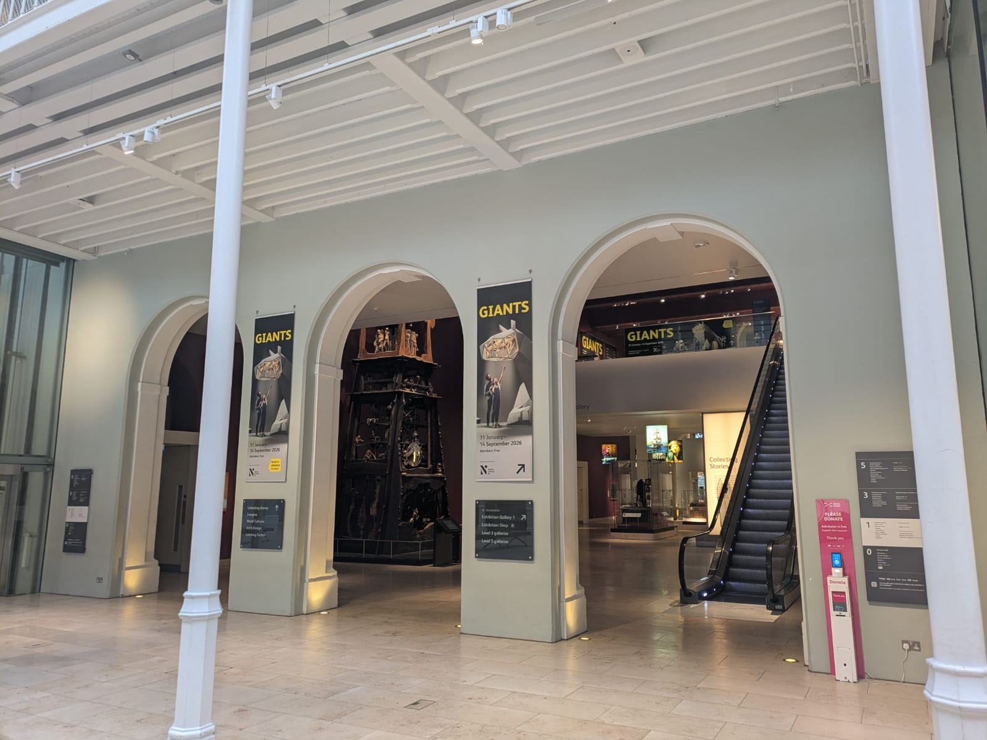
The entrance to the exhibition is on Level 3. Staff at the ticket desk will scan your ticket (the scanner beeps when used).
If you do not have a ticket, you can book one at the exhibition ticket desk if available.
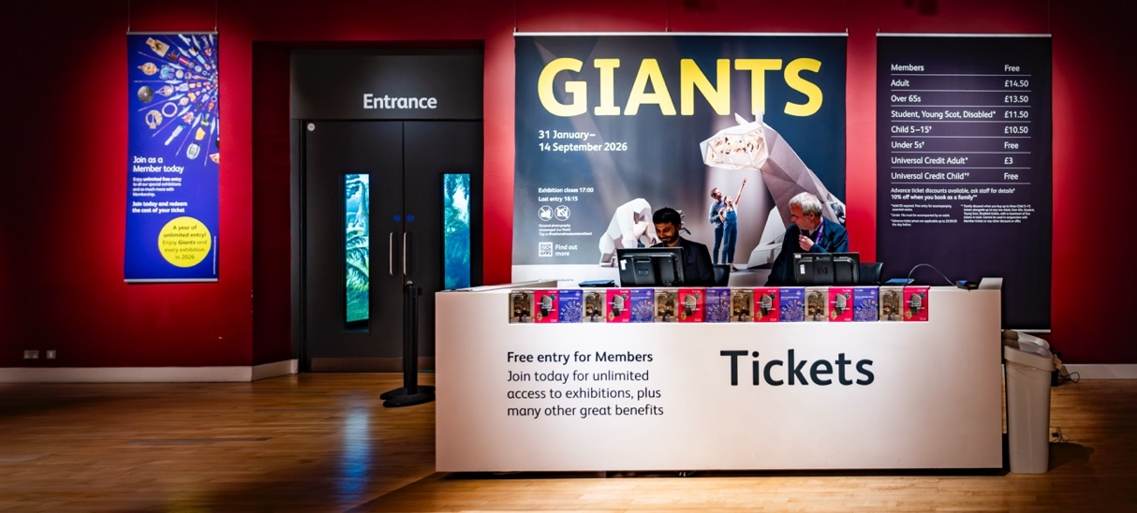

Toilets
The nearest toilets (including an accessible toilet) to the exhibition are on Level 3 through the Making and Creating gallery. There is a Changing Places (U) toilet available in the Level 0 Entrance Hall. It is opened with a RADAR key. One is available at the information desk next to the toilet entrance if you do not have your own. Toilets and accessible toilets are available on every level of the museum.

Exhibition Sensory Map
A sensory map for the exhibition is available online:
Giants sensory map
There are also printed copies available at the Exhibition ticket desk.

A visual walk through the exhibition
Giants features ten life-sized 3D sculptures of extinct prehistoric creatures. Most of the sculptures include pictures and information, as well as display cases with fossils, touch opportunities and films with headsets.
At the entrance, there are three wall-size screens surrounding you featuring text and hand-drawn animated images showing the history and current situation of giant wild animals. There is a soundtrack with animal noises.
Large print text booklets are available to borrow from a holder on the wall here. Please return these at the end of your visit.
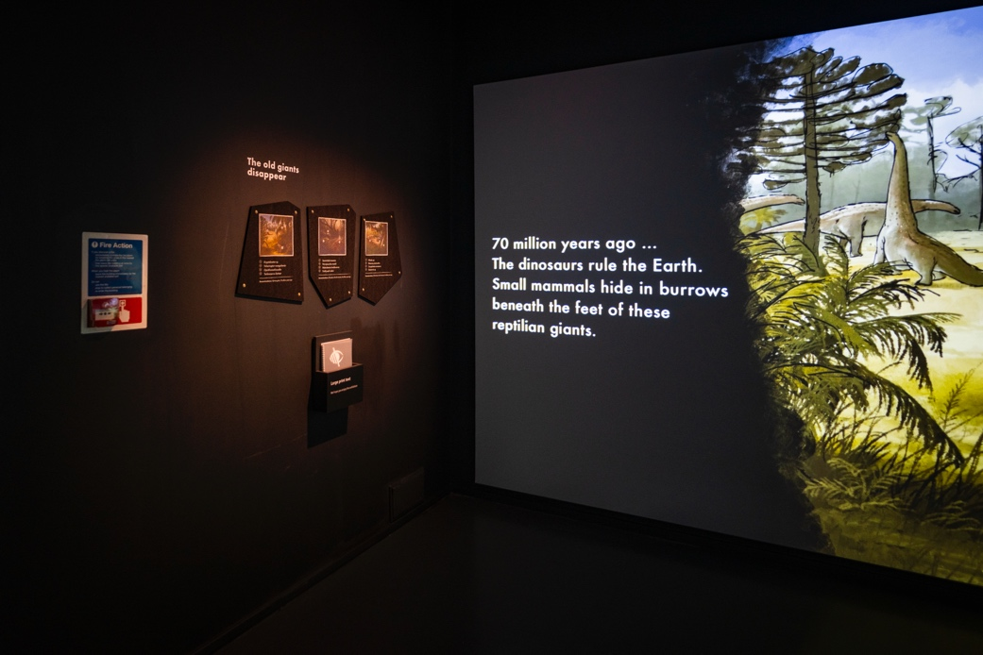
The first sculpture in the exhibition is Titanoboa cerrejonensis (Giant snake).
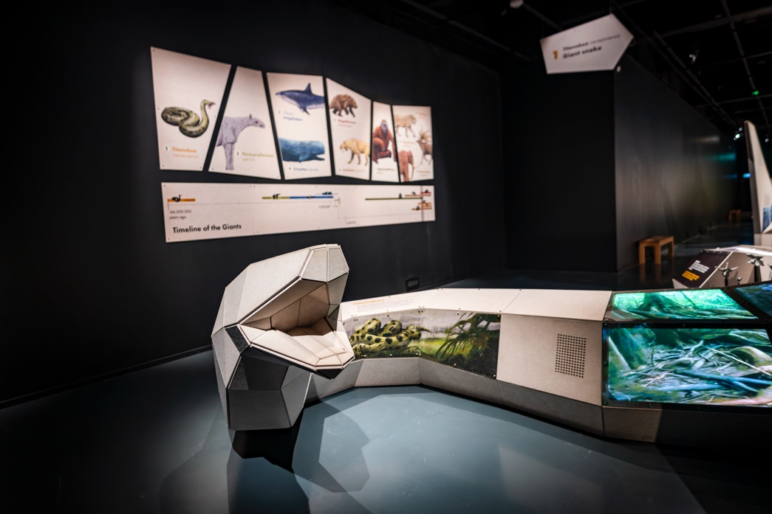
There is a screen on the sculpture showing moving images and a hollow display case showing replica fossils. There is also a video on a touchscreen with headsets to listen to the audio and a display of fossils which you can touch.
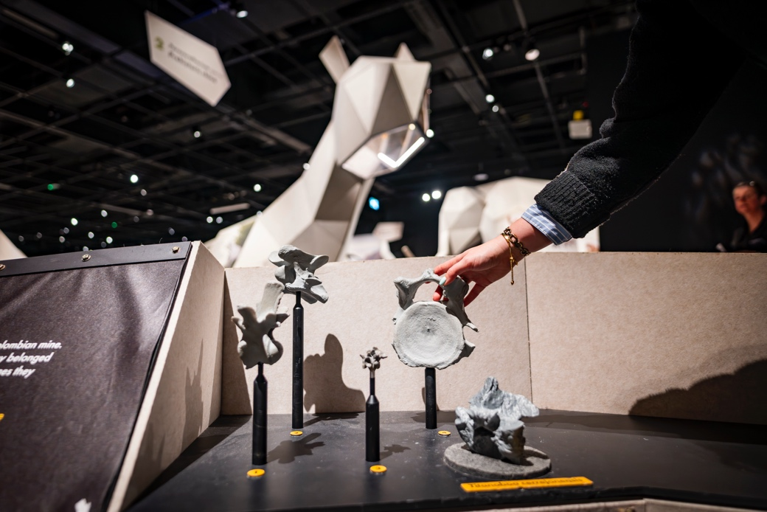
Behind the sculpture there is a holder with children’s trails to borrow.
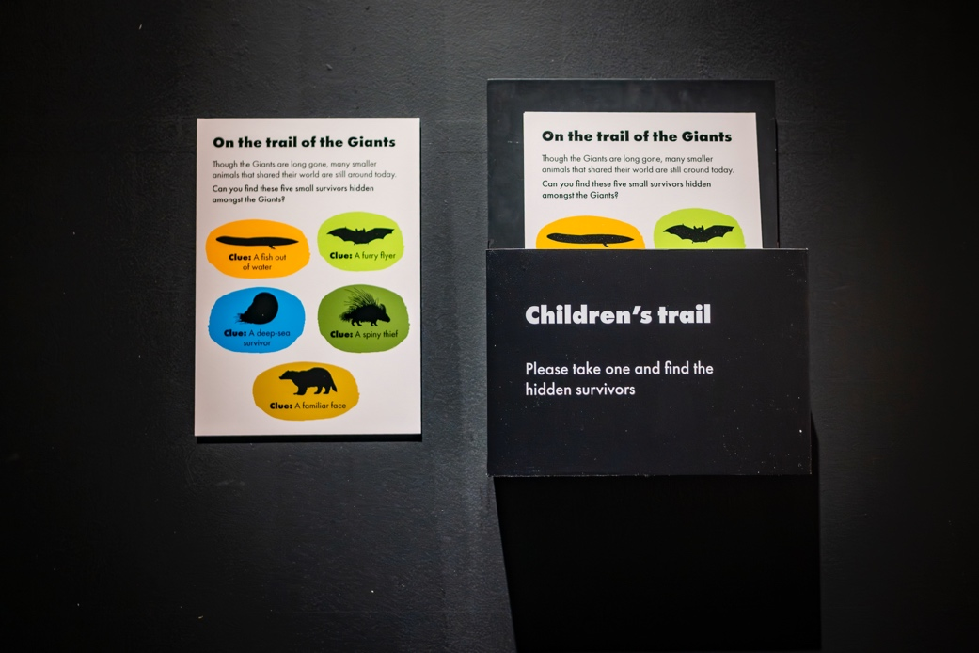
Next is the Paraceratherium species (prehistoric rhino). You will hear the sounds of a rhino and running water. The video features animals hunting. There is also a video on a touchscreen with a headset to listen to the audio. There is also a display of fossils which you can touch.
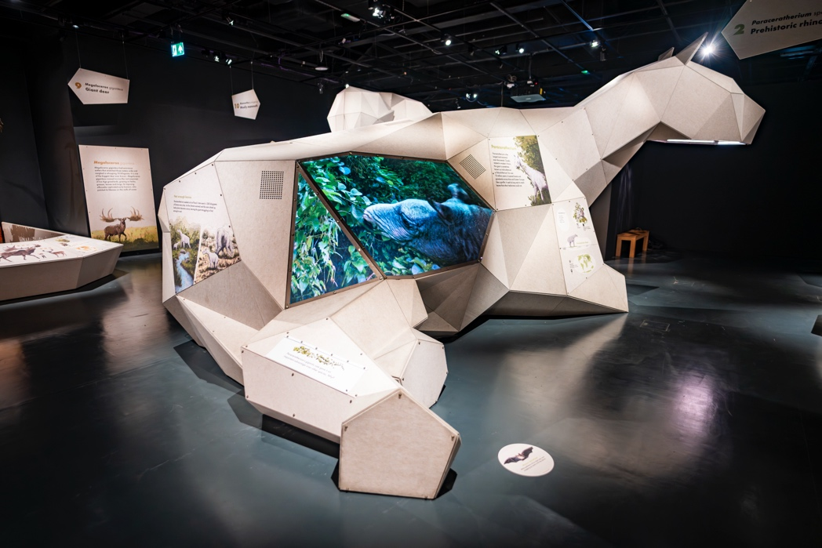
Keep going and you will find the sculpture of Otodus megalodon (Megatooth shark). In the middle of the sculpture, you can find interactive displays and a touchscreen showing a video with a headset to listen to the audio.
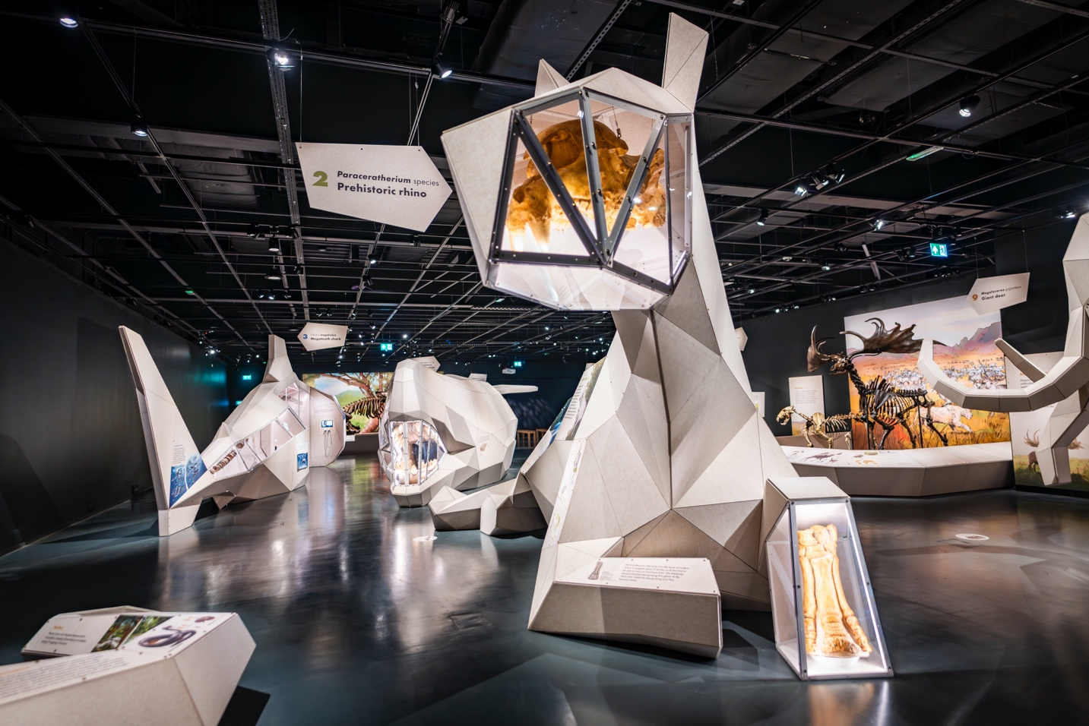
Opposite the shark is the Livyatan melvillei (prehistoric sperm whale) sculpture. Inside, there is a screen showing video footage of the whale and shark and to the left is a touch screen with a game you can play.
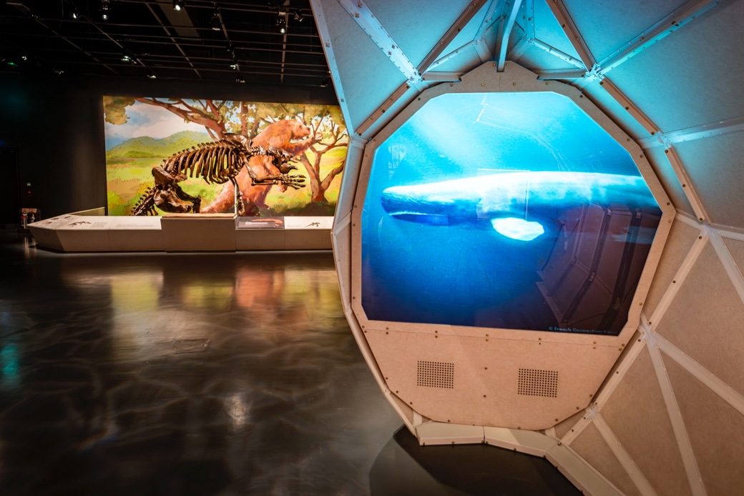
This is a replica skeleton of the Megatherium americanum (Giant ground sloth). The lighting is lower here. There is a touch display in front of the exhibit and a video on a touch screen with a headset to listen to the audio.
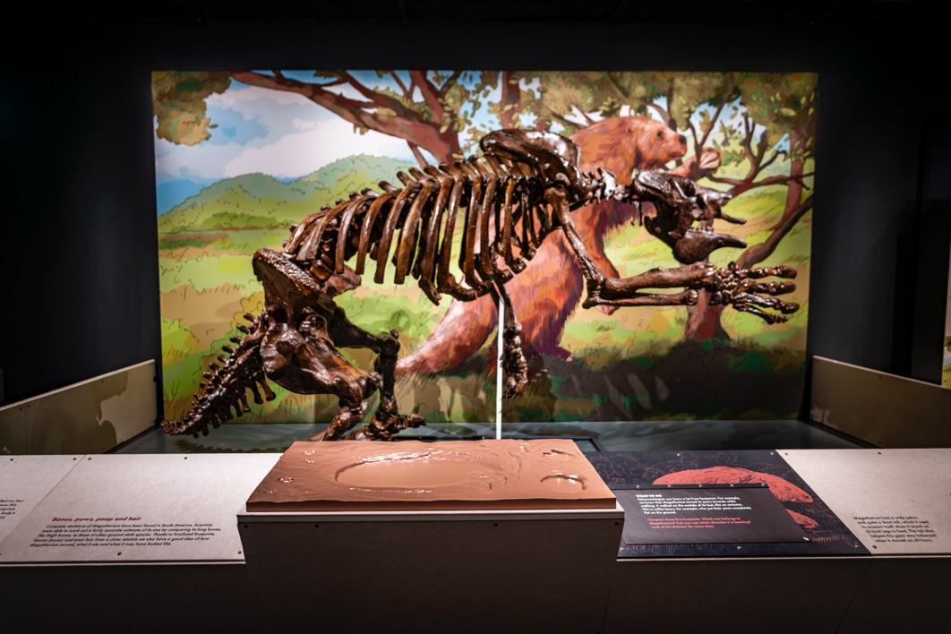
To the right, a screen shows saber-toothed cats and the giant ground sloth in action (including hunting scenes). Two wooden benches are available for seating. Please note the lighting is low in this area.
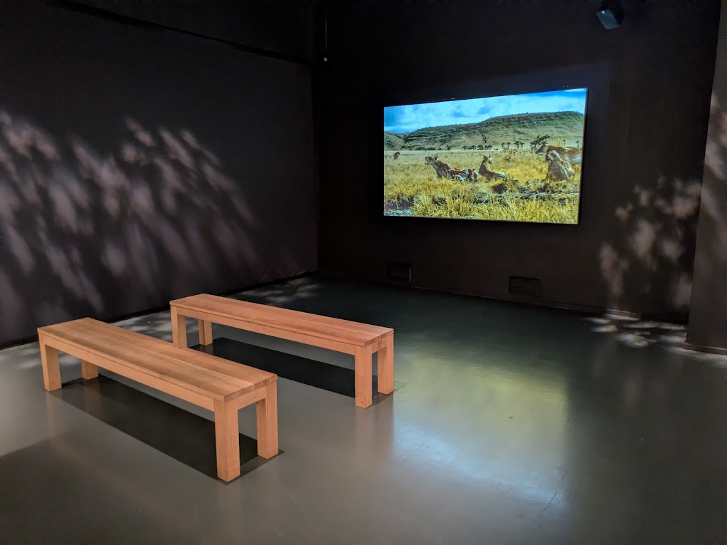
To the right of the video screen, there’s a replica skeleton of the Smilodon populator (sabre-toothed cat). This display also includes an interactive exercise with questions and answers and a video on a touch screen with a headset for audio.
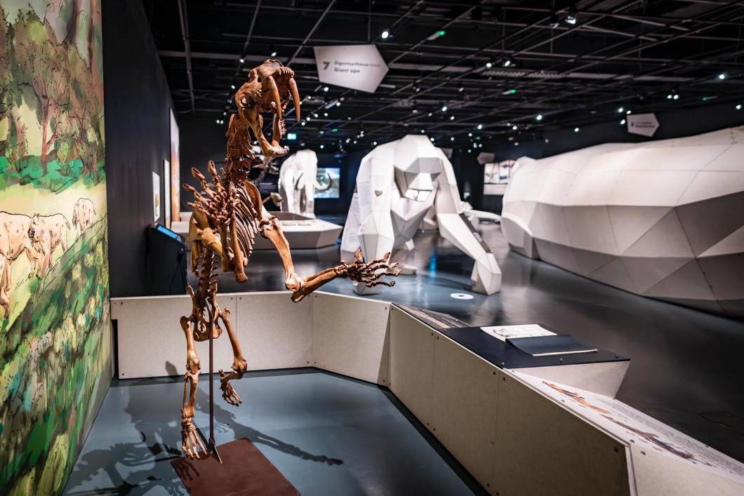
Continue forward to see the sculpture of Giantopithecus blacki (giant ape). This has a video on a touchscreen with a headset for audio and to the side is a freestanding touchscreen with an interactive game.
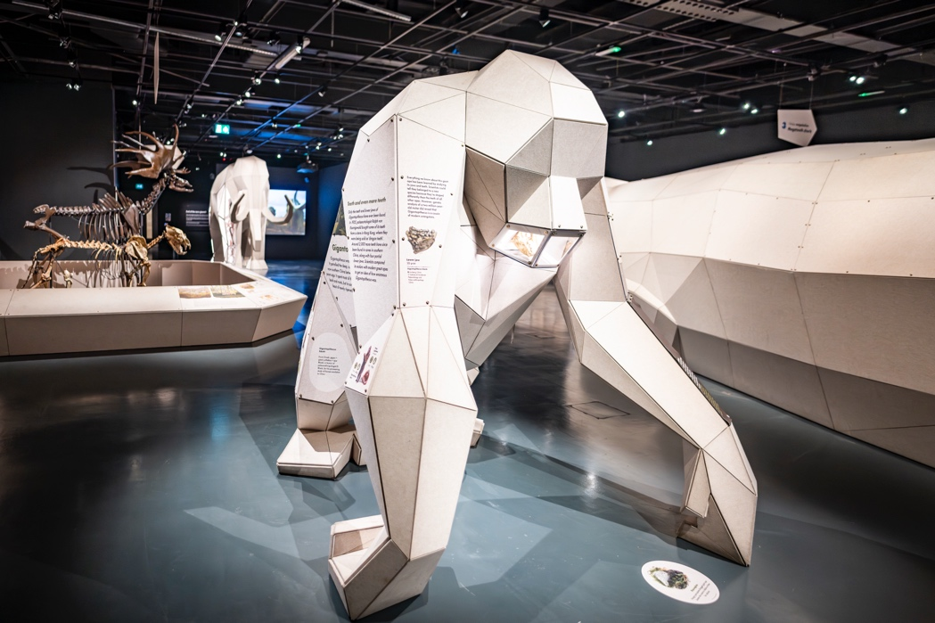
Further ahead, there are replica skeletons of the Panthera spelaea (cave lion) and the Megaloceros giganteus (giant deer).
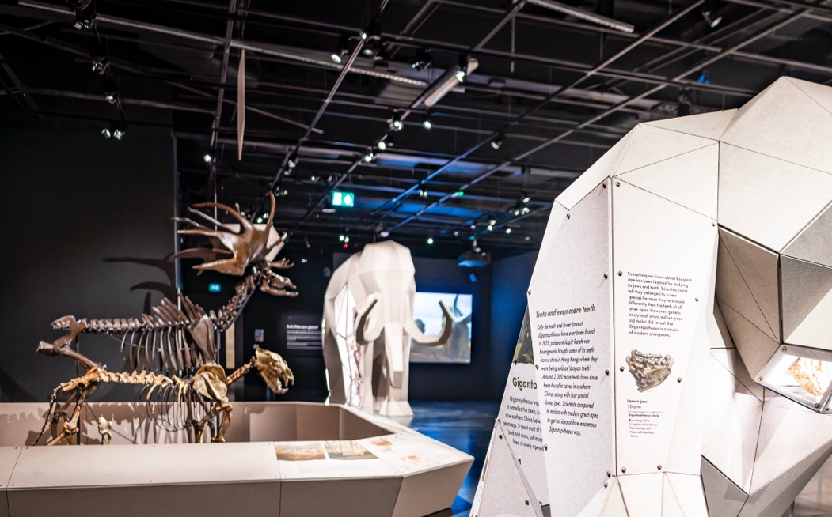
The final sculpture is the Mammuthus primigenius (Woolly Mammoth). This area is brighter. Behind the mammoth, there is a large screen showing a video which includes hunting scenes. Next to the mammoth is a video on a touchscreen with headsets for audio and a wooden bench against the wall.
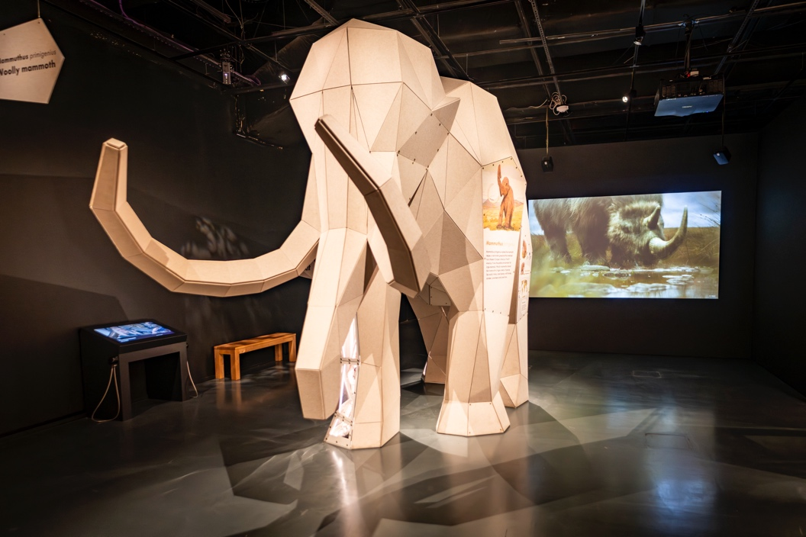
The exit area is dimly lit and features four wooden benches where you can sit and enjoy the video. It is 19 minutes long and shows on a loop.
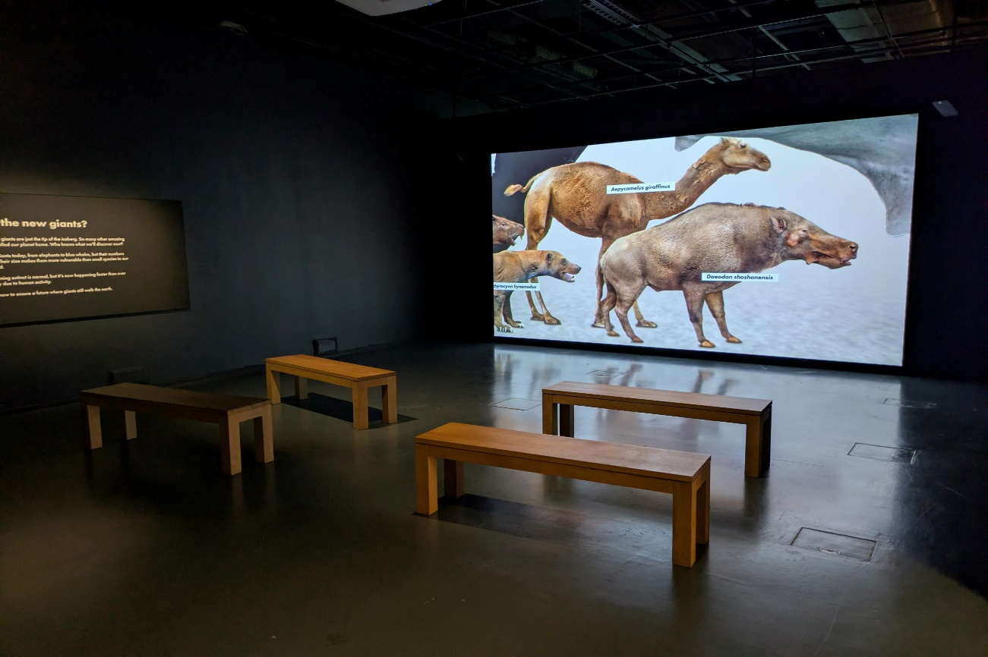

Exhibition exit and shop
You will exit the exhibition through this door. Please return trails and large print labels.
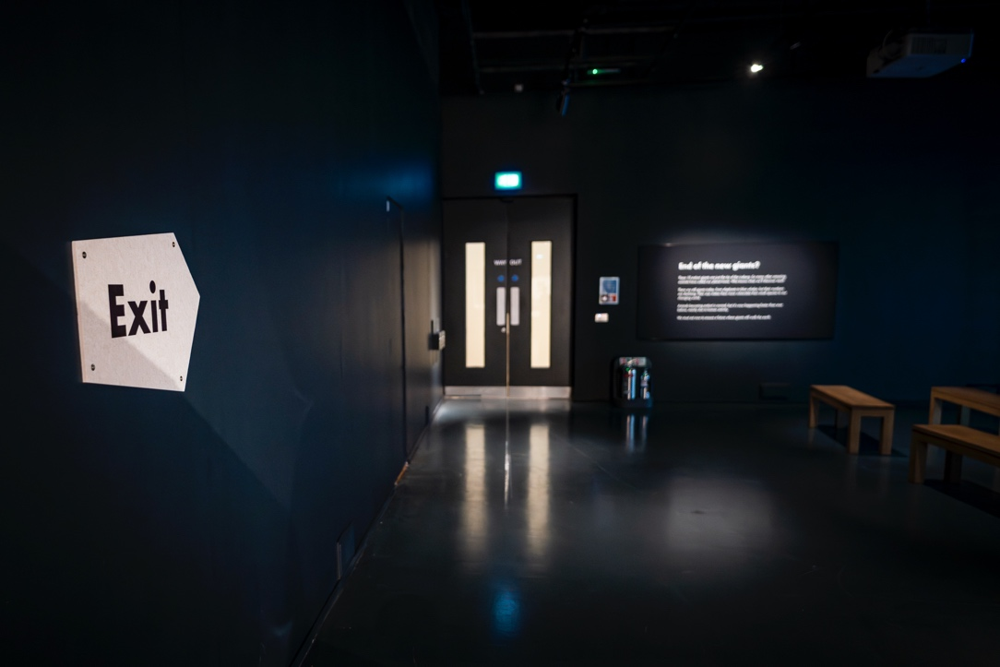
The Exhibition Shop is opposite the exit.
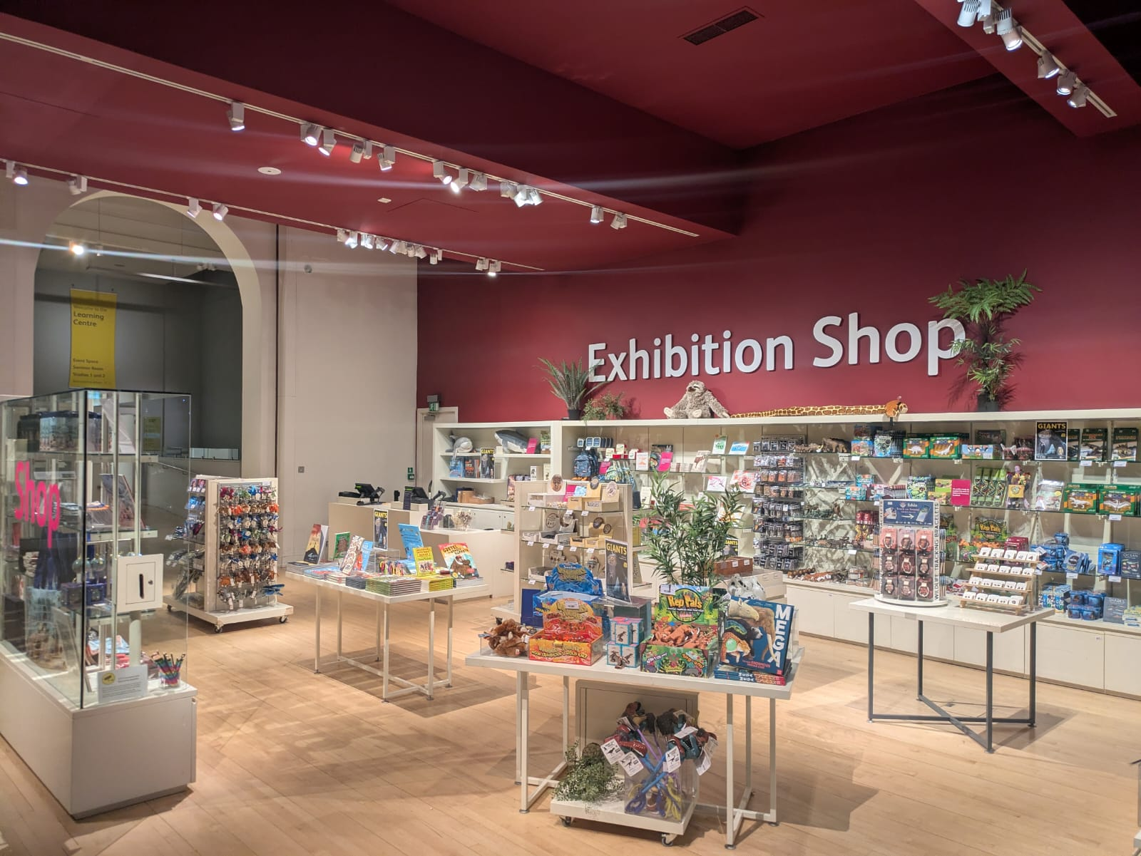
We hope you enjoy your visit.

Contact us
If you require any further information about the museum or the exhibition, please use the following contact details:
Email: communities@nms.ac.uk
Call: 0300 123 6789 (Monday to Friday, 10:00 to17:00)
Or visit our website www.nms.ac.uk

