Monkeys: Our Primate Family
28 June – 30 November 2025
Visual Guide

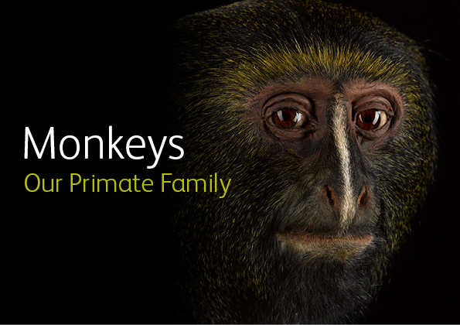

National Museum of Scotland
Chambers Street
Edinburgh
EH1 1JF

This visual guide is designed to support a visit to the exhibition Monkeys: Our Primate Family at the National Museum of Scotland.

Visiting the National Museum of Scotland 1
Visiting the exhibition 3
General information 4
Notes on the exhibition 4
Relaxed Viewings of Monkeys: Our Primate Family 4
Getting to the exhibition 5
Toilets 6
Exhibition Sensory Map 7
A visual walk through the exhibition 8
Exhibition exit and shop 36
Contact us 38

Visiting the National Museum of Scotland

There are two entrances to the National Museum of Scotland.
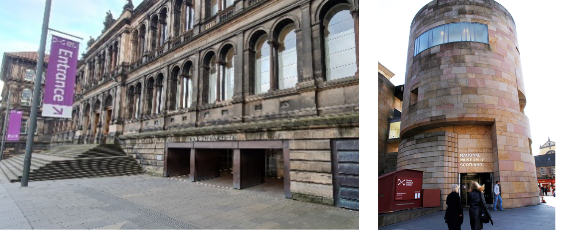
The Main Entrance The Tower Entrance
The Tower Entrance is usually quieter and offers step-free access to the museum.
Please visit our ‘Plan Your Visit’ webpage: https://www.nms.ac.uk/national-museum-of-scotland/plan-your-visit/ for more information about getting to the museum, facilities, and accessible parking. You can also download a map of the museum.
Guide dogs and assistance animals are welcome in all areas of the museum.
General visual stories are available to support your visit:
Main Entrance Visual story
Tower Entrance Visual story
To find out more about accessibility at the museum please visit: https://www.nms.ac.uk/national-museum-of-scotland/plan-your-visit/accessibility/

When you arrive at the museum, there are information desks at both entrances. If you would like to pick up a map or if you have any questions, our Visitor Experience staff can help you.
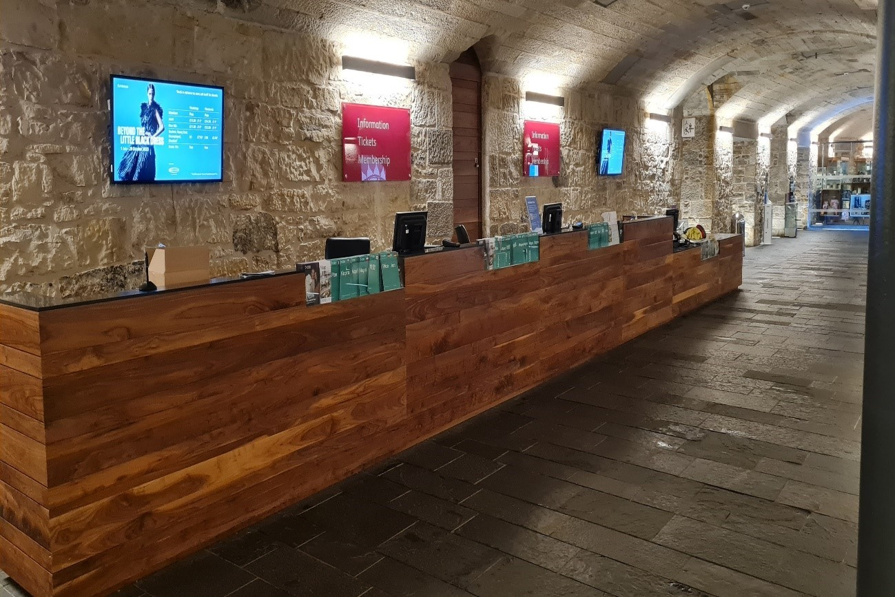
Our visitor experience staff wear purple shirts and lanyards and are available throughout the museum.
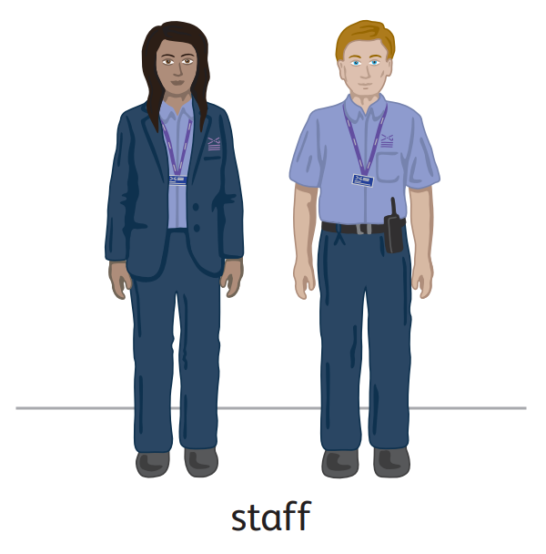

A limited number of sensory maps of the museum and sensory backpacks are available to borrow for free from the information desks.

Visiting the exhibition

General information
'Monkeys: Our Primate Family' brings together more than 50 taxidermy specimens, including monkeys, apes, lemurs and lorises. Visitors will discover how primates have evolved and adapted to travel and hunt for food, how primates communicate, and their complex social systems.
Visitors will hear about the ongoing conservation efforts to protect primates in the wild and learn how to make a difference to their survival.

Notes on the exhibition

- This exhibition is ticketed. Tickets are available online Monkeys: Our Primate Family | NMS or on the day from the Entrance Hall desk or the exhibition desk. Relaxed Morning viewings of Monkeys require ticket bookings.
- Personal photography is encouraged but flash is not allowed. Filming is permitted for personal, not-commercial use, on a personal device.
- No eating or drinking in the exhibition.
- There are wooden benches available in the exhibition. Portable foldable stools are also available at the exhibition entrance.
- Large print guides are available in a holder through the entrance door to the left as you go in.
- Light levels vary throughout the exhibition as indicated on the sensory map.
- Child/adult ear defenders are available to borrow from the Exhibition Desk.
- For more information about the accessibility of the exhibition please visit the exhibition website: Monkeys: Our Primate Family | NMS

Relaxed Viewings of Monkeys: Our Primate Family

Relaxed viewings of Monkeys: Our Primate Family will be held at the following dates/times:

Sunday 3 August, 10:00 – 12:00
Sunday 7 September, 10:00 – 12:00
Sunday 5 October, 10:00 – 12:00
Sunday 2 November, 10:00 – 12:00

During Relaxed Viewings, visitor numbers will be reduced and the volume of some of the visual displays.
You can find further information about our Relaxed Morning sessions here: Relaxed Morning: Monkeys: Our Primate Family | NMS

Getting to the exhibition
Monkeys: Our Primate Family is in Special Exhibition Gallery 1 on Level 3 of the museum.
Level 3 is accessible via a lift, an escalator, or stairs.
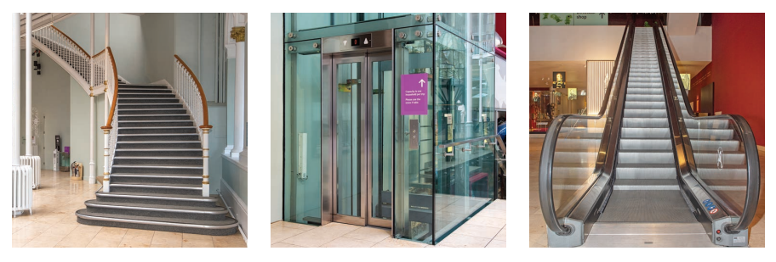
The entrance to the exhibition is on Level 3. Here you will be greeted by museum staff.
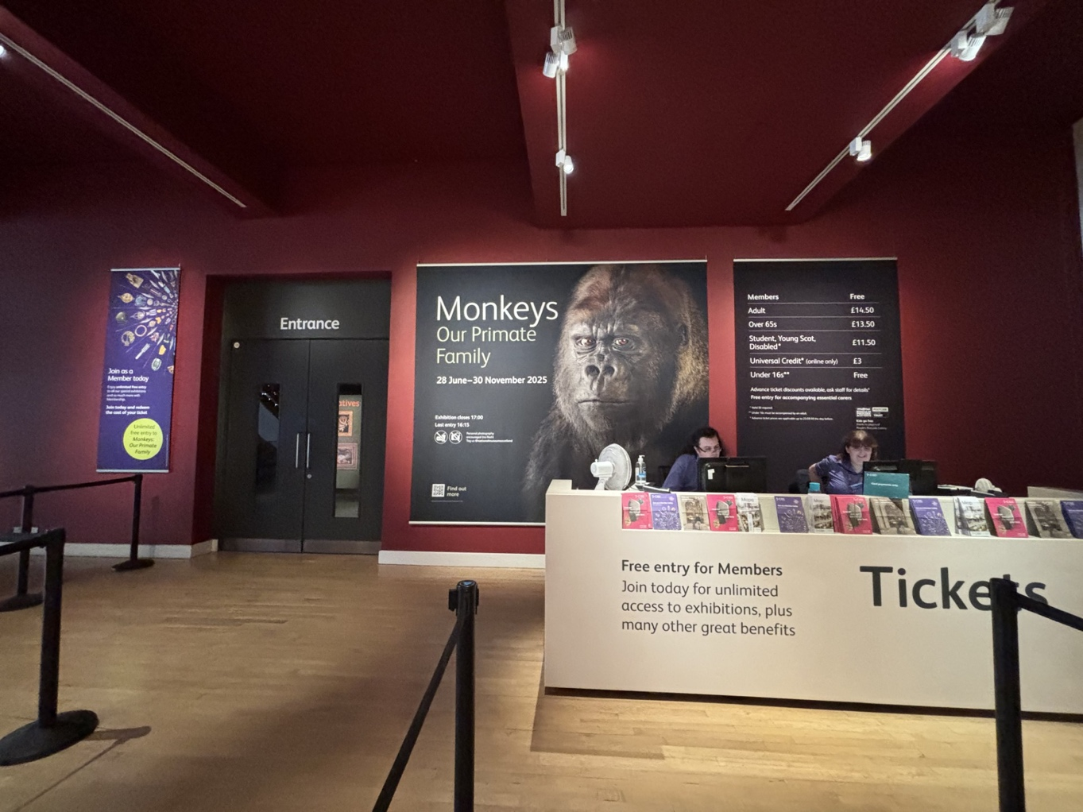

Toilets
The nearest toilets (including an accessible toilet) to the exhibition are on Level 3 through the Making and Creating gallery. There is a Changing Places (U) toilet available in the Level 0 Entrance Hall. It is opened with a RADAR key. One is available at the information desk next to the toilet entrance if you do not have your own. Toilets and accessible toilets are available on every level of the museum.

Exhibition Sensory Map
Printed copies of the Sensory Map are available to borrow from the Exhibition Information Desk on Level 3.
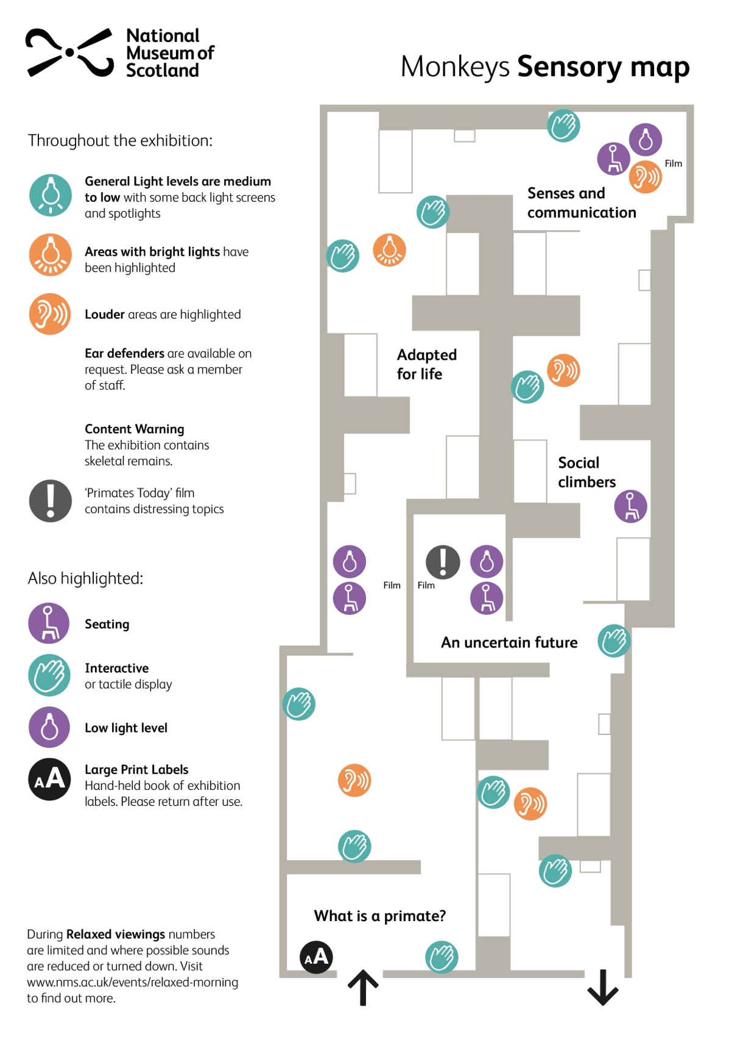

A visual walk through the exhibition

What is a Primate?

In the beginning you will see large a wall displaying two mirrors and pictures of monkeys titled ‘Meet the relatives’.
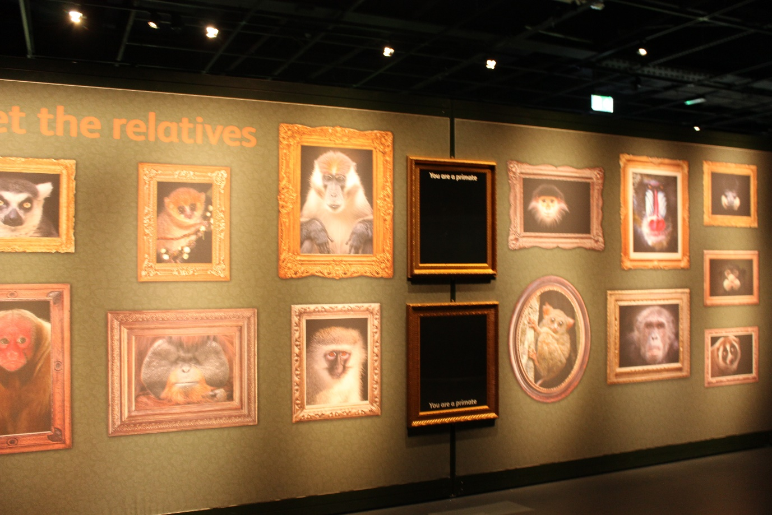

Large print labels and copies of the exhibition text are available to borrow from stands on the left hand side of the entrance as you go in. Please return them to the stands by the exit when you have finished your visit.

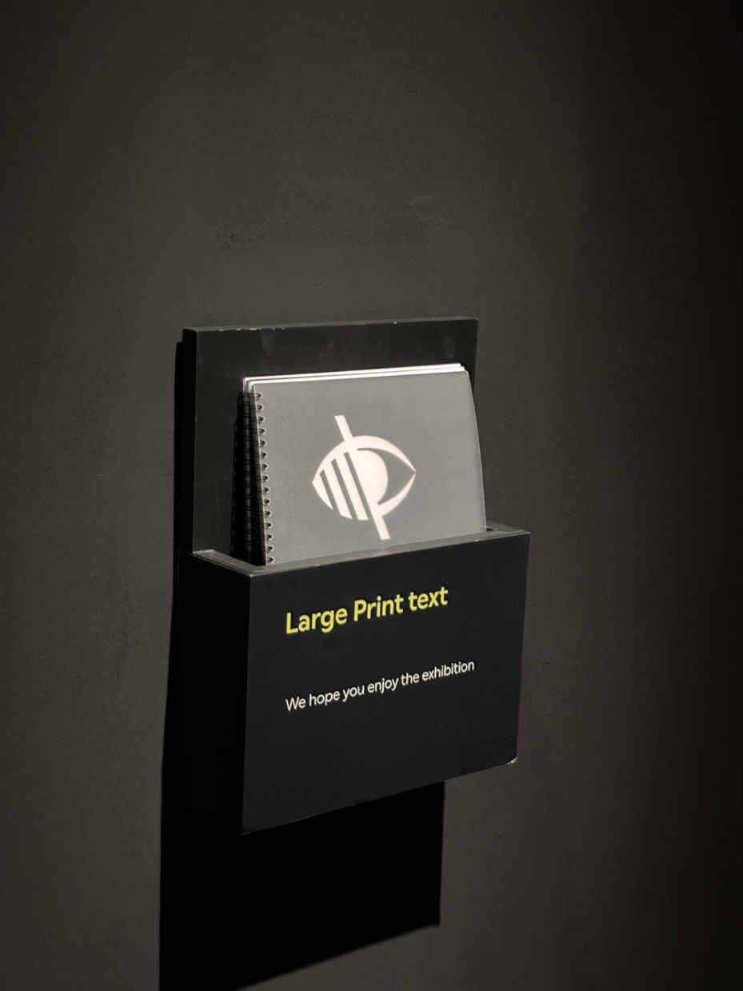

When entering, there is a board containing information about the exhibition.

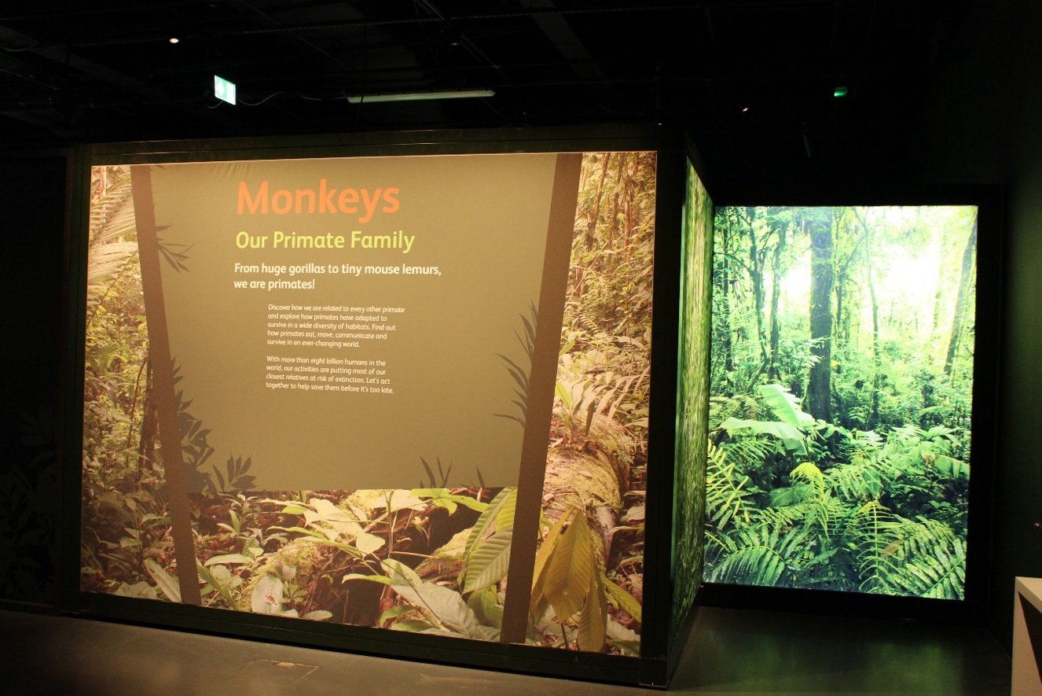
Interactive: stamp station
As you enter the exhibition, there is an interactive stamp activity to the right. There are two more stations further into the exhibition with different stamps for visitors to use on bookmarks provided on the table. The first stamp is of a gorilla.
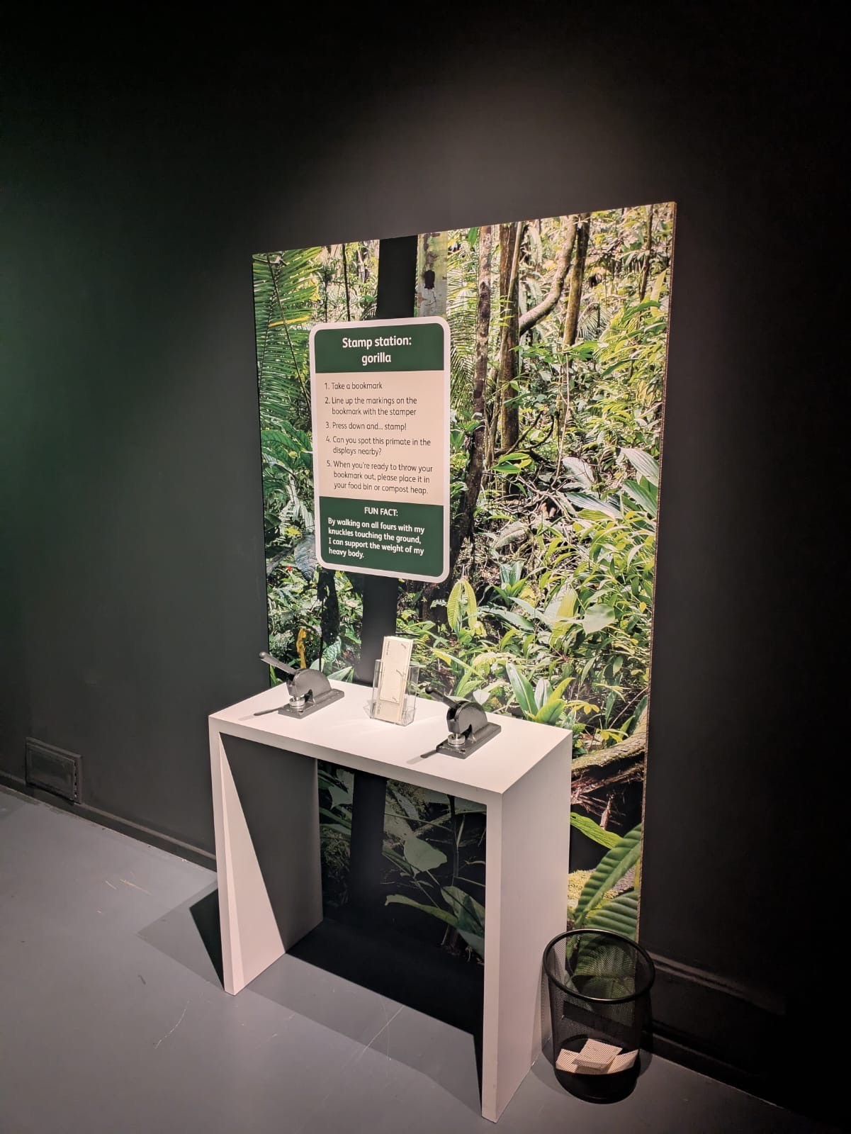

The first section of the exhibition contains information about primates and primate ancestry. There is an interactive screen under the ‘Meet the ancestors’ information section with a stool. This interactive does not have any sound. This section contains skeletal remains including skulls behind a glass case.
There is atmospheric jungle noise throughout the exhibit. This area contains a louder monkey call which increases and decreases in volume.
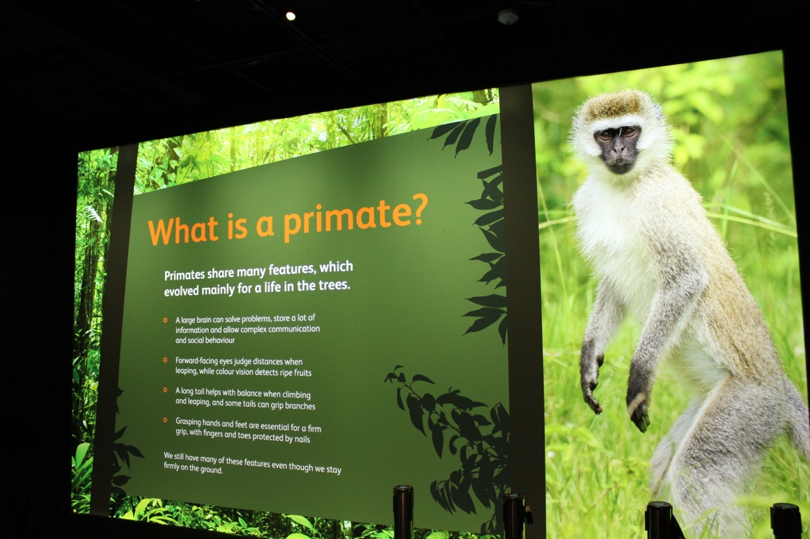
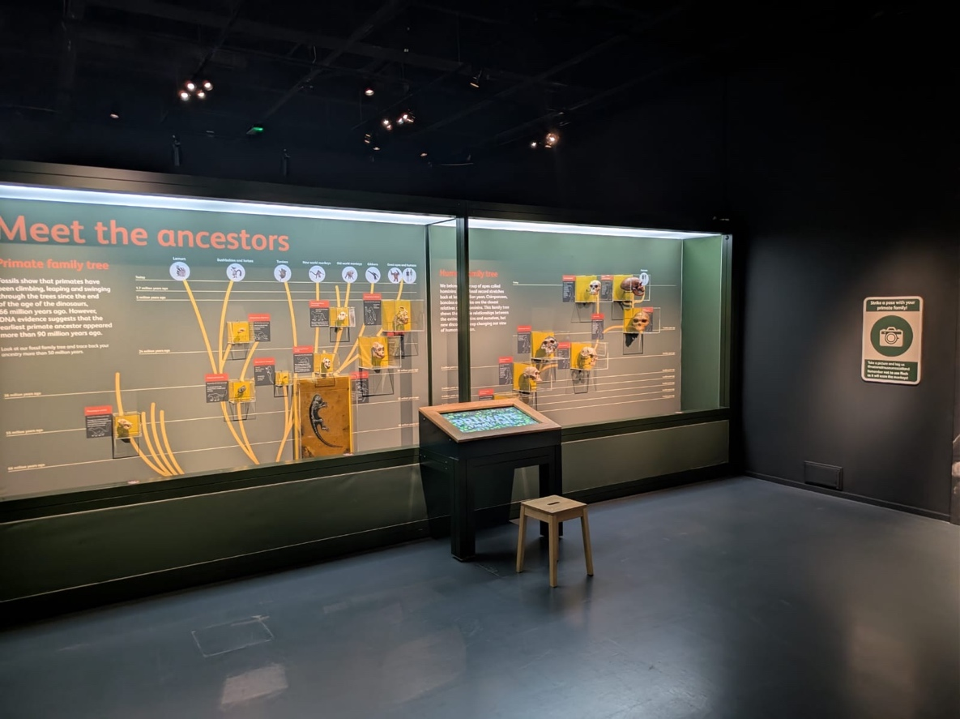

Photograph opportunity

Photography is allowed however we ask visitors to not use flash. There are multiple signs stating this, one on a column in the centre of the space and one on a wall. This wall contains images of multiple primates with space for visitors to stand in the middle and take pictures.

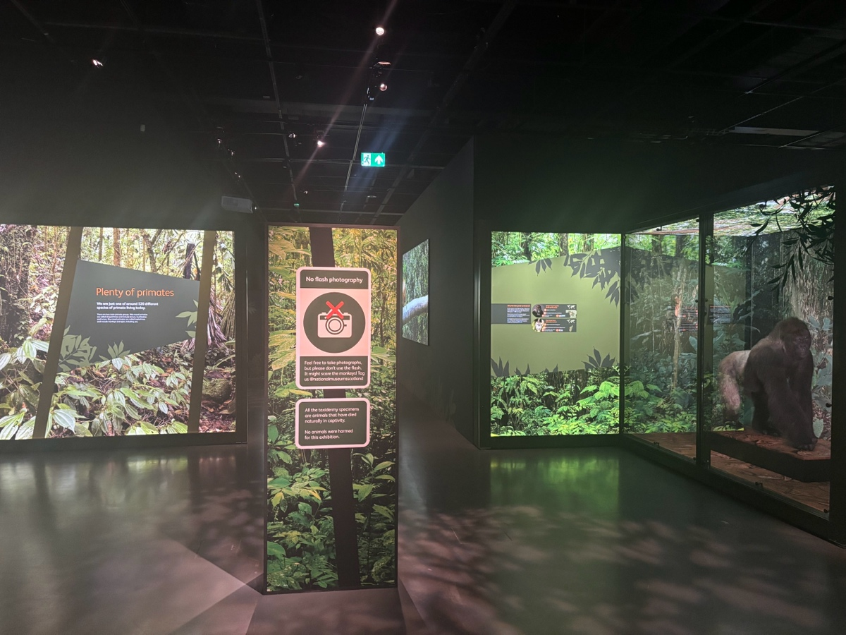
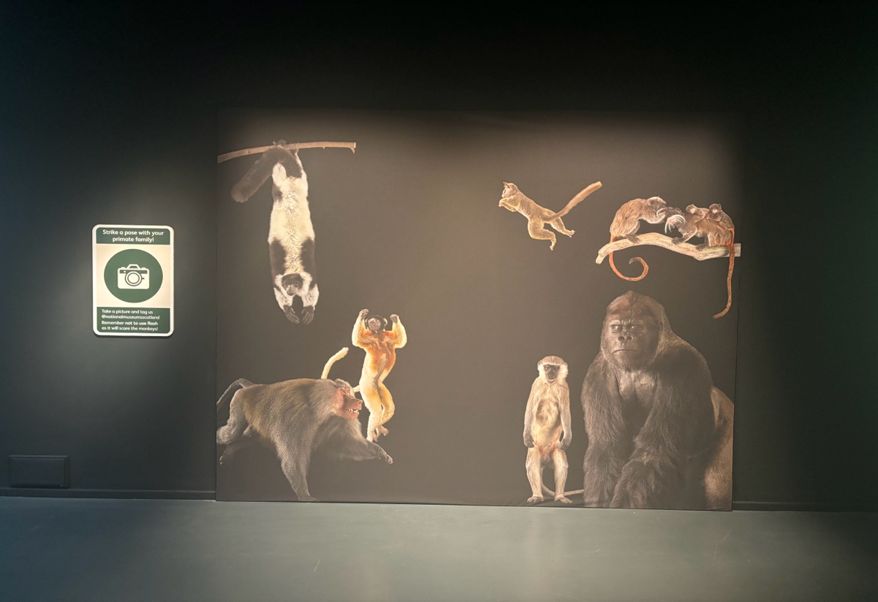

Interactive
This area contains another interactive screen activity titled ‘Human Jigsaw’. This interactive does not have any sound.
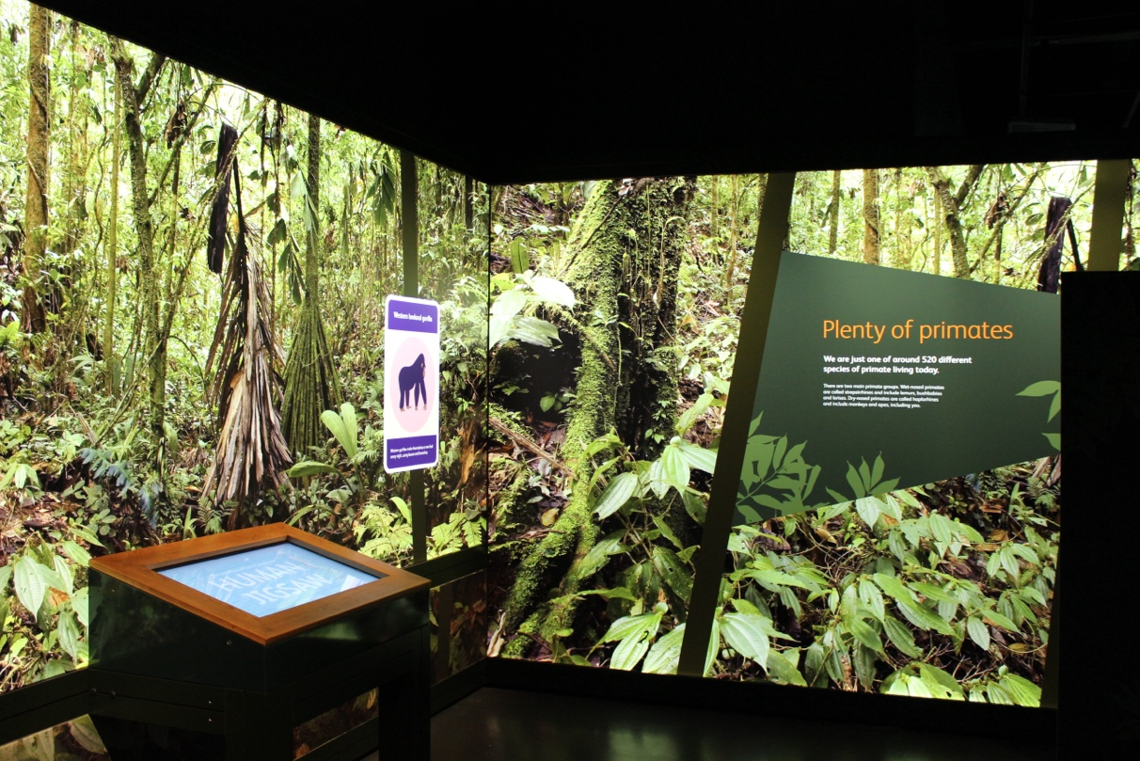
Film
There is a projected film and some benches for seating in the next section. This area has a lower level of lighting and the film has sound.

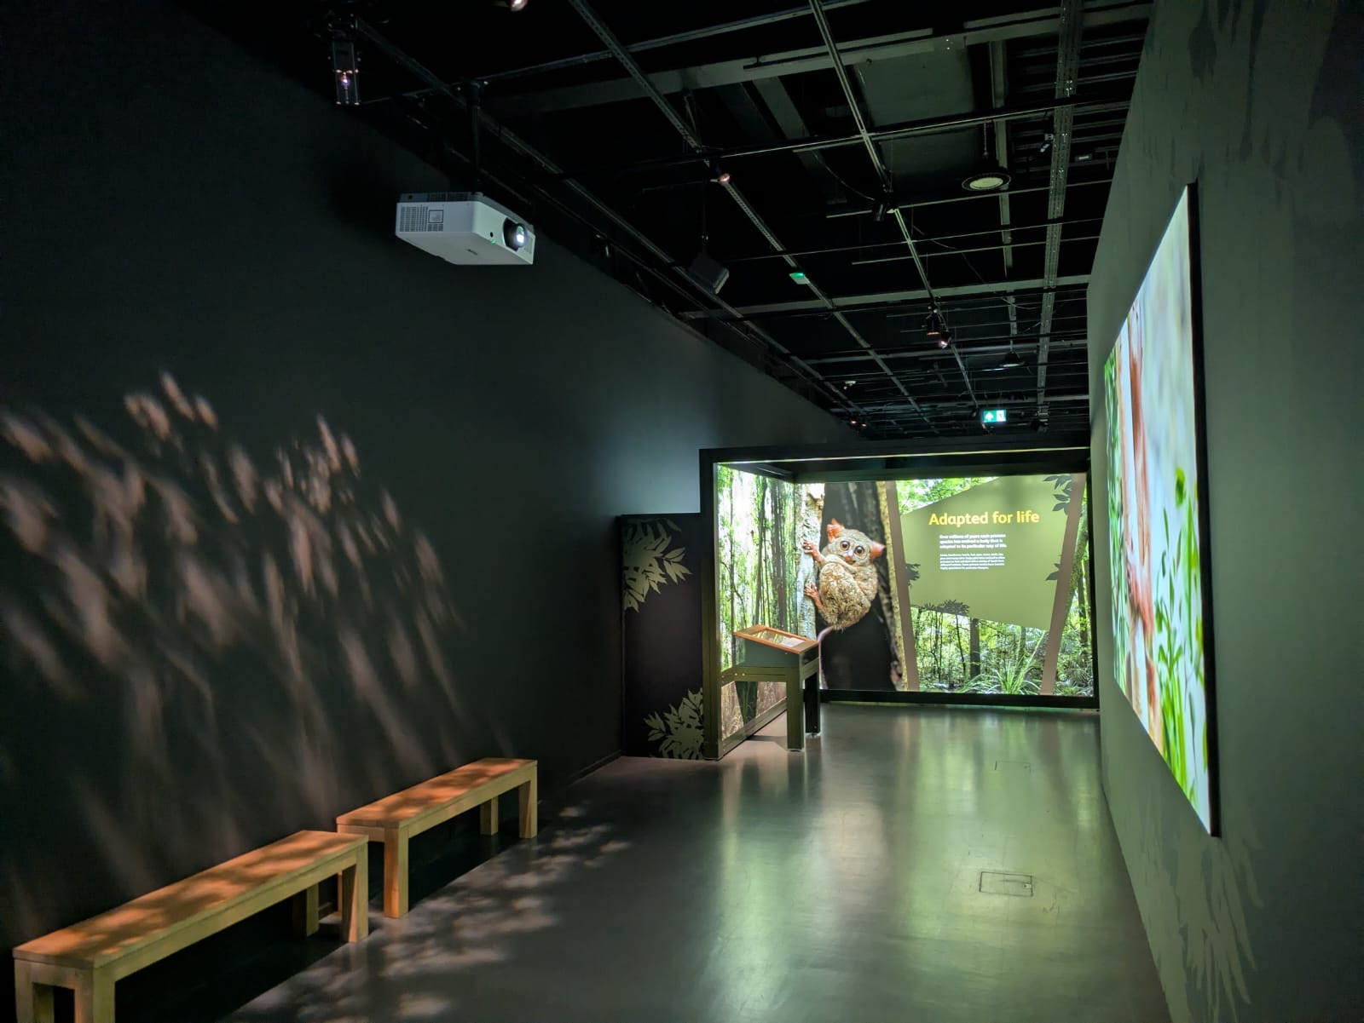

Adapted for Life
This section of the exhibit explains how primates have adapted over time through evolutionary changes to their bodies.

Interactive
This area has an interactive screen activity called ‘Monkey Supermarket’ at the ‘Feeding Frenzy’ information wall. This interactive activity does not have any sound.
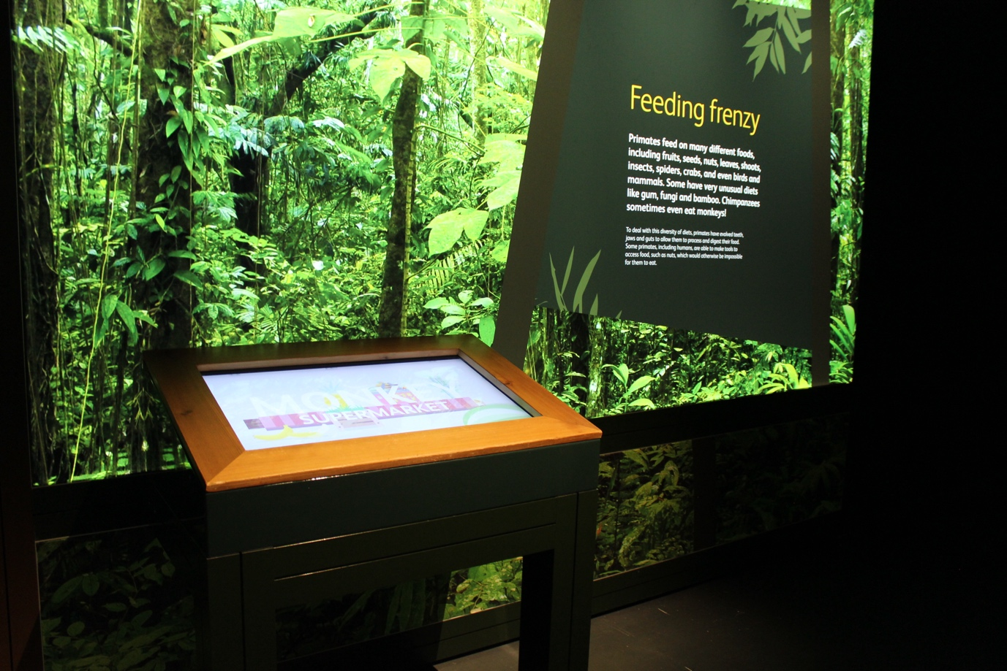

Interactive
This interactive requires visitors to push a button and look into the tree hole to see a hibernating dwarf lemur. This interactive does not have any sound but is in a brightly lit area.

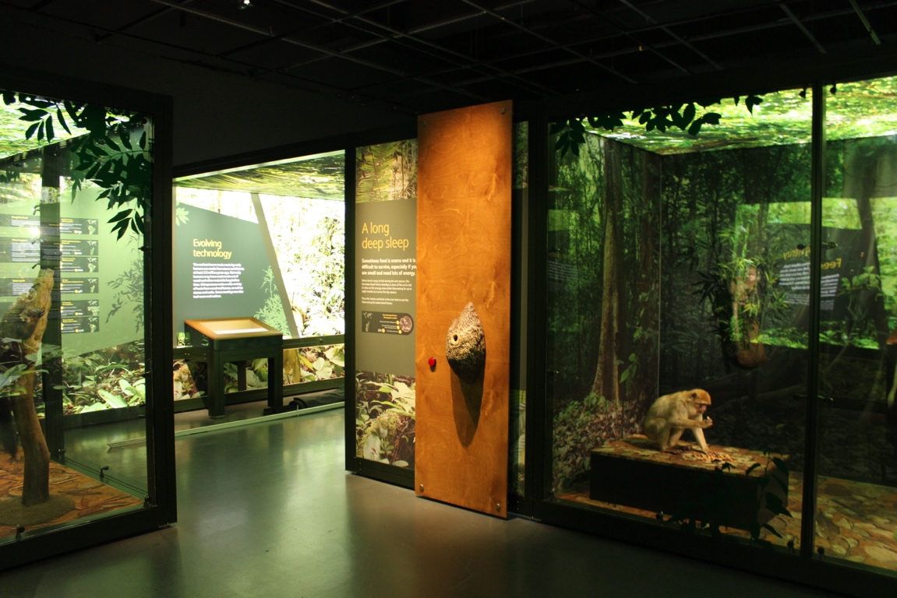

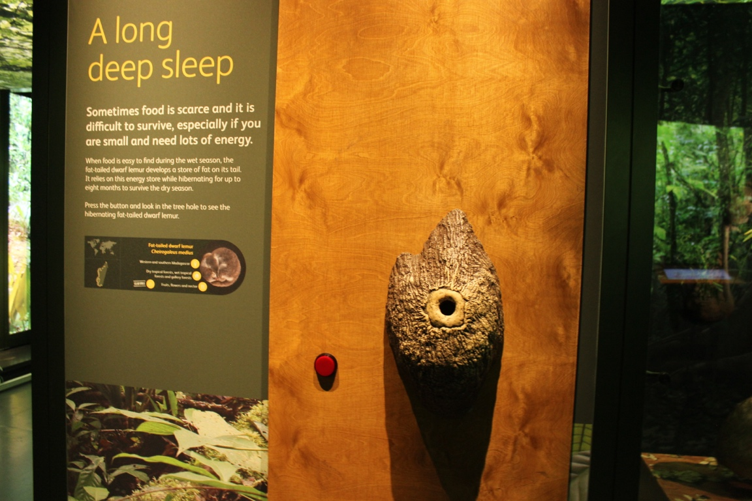

Senses and Communication
This section informs visitors about how primates have adapted to use tools and their senses for survival. This area has a tunnel leading to the next section.

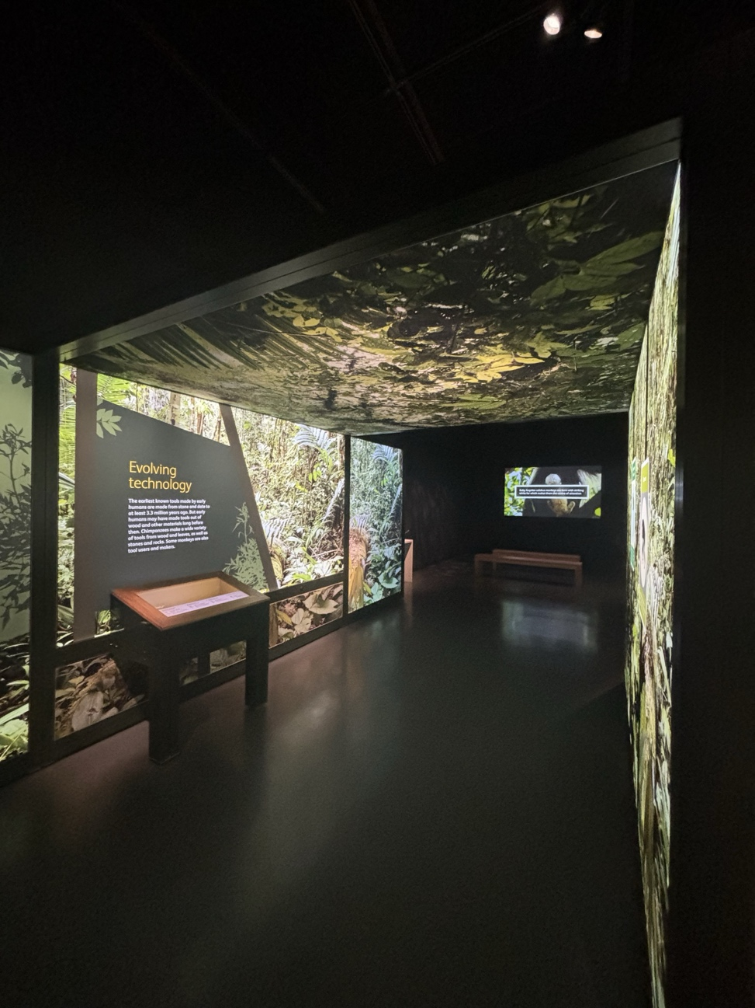

Interactive: stamp station
This is another stamp station where visitors can stamp a tamarin onto their bookmarks.
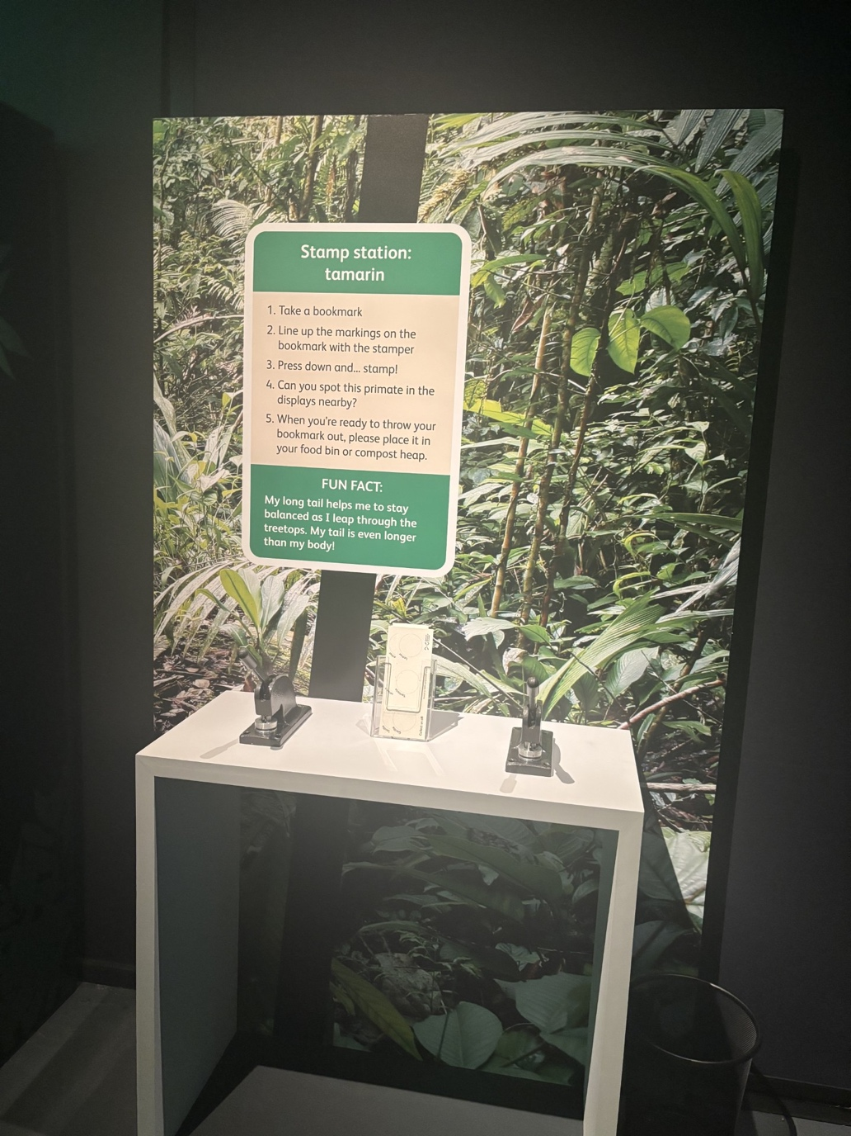

Film
This section has a projected film and some benches for seating. This area has a lower level of lighting and the film has sound.

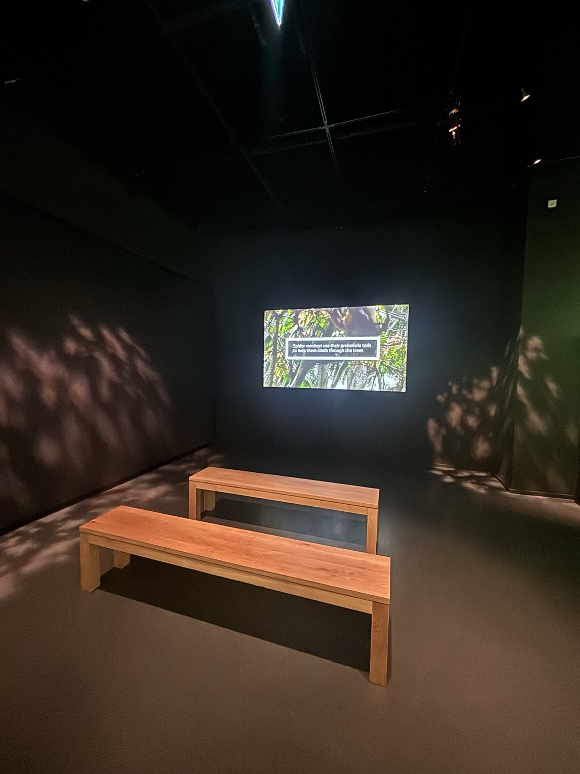

Interactive
Visitors can look through the goggles attached to the wall to see different forms of primate vision. Each goggle has small round label with pictures showing which primate they belong to. The red symbol above the goggles asks that visitors do not press the round labels.
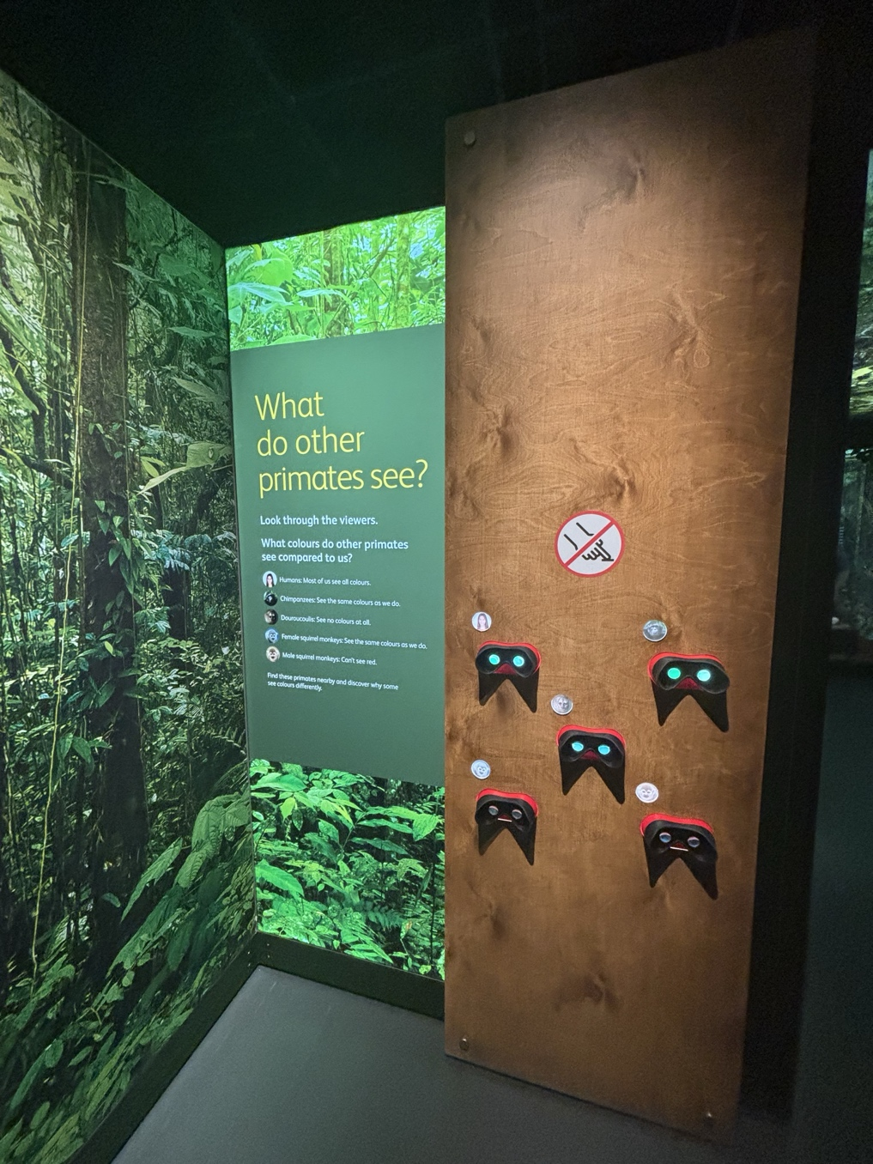

Interactive
In the ‘Making Sense’ section, there is an interactive screen and audio activity called ‘Jungle Talk’. This interactive asks visitors to match monkey calls with text on the screen. One of the monkey calls is a higher pitch, which the screen will warn visitors about before it plays.

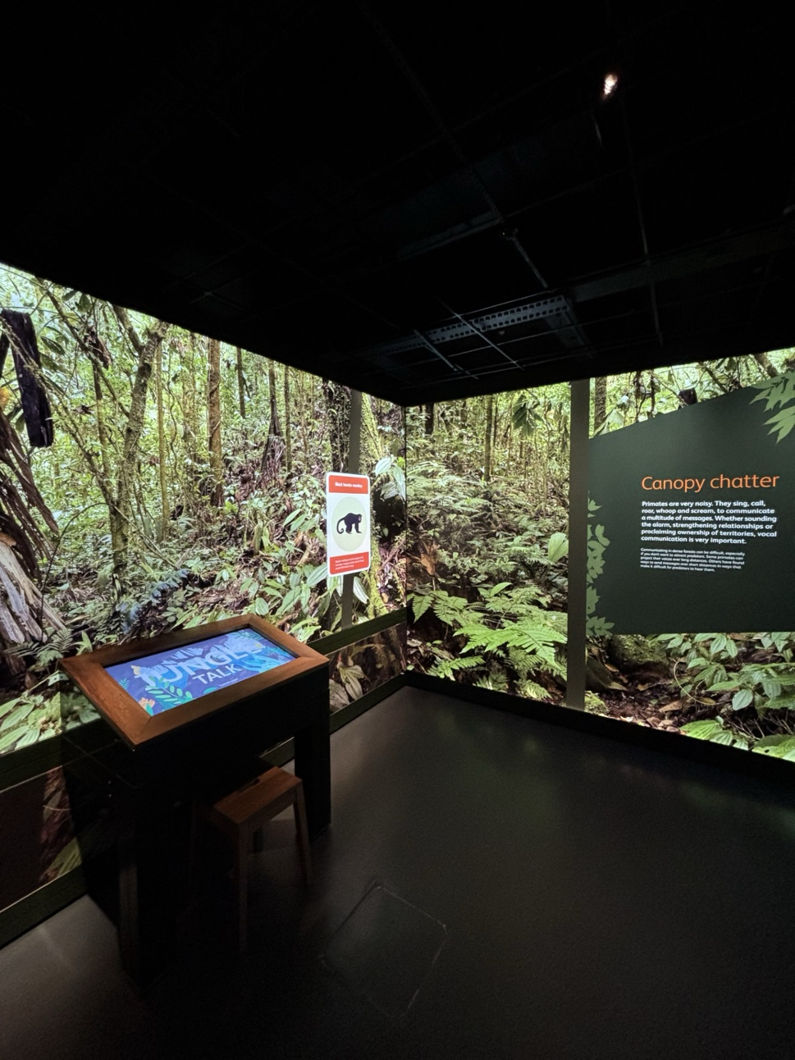

Social Climbers
This section informs visitors about the different types of primate social groups and their advantages, as well as primates who live prefer to alone.
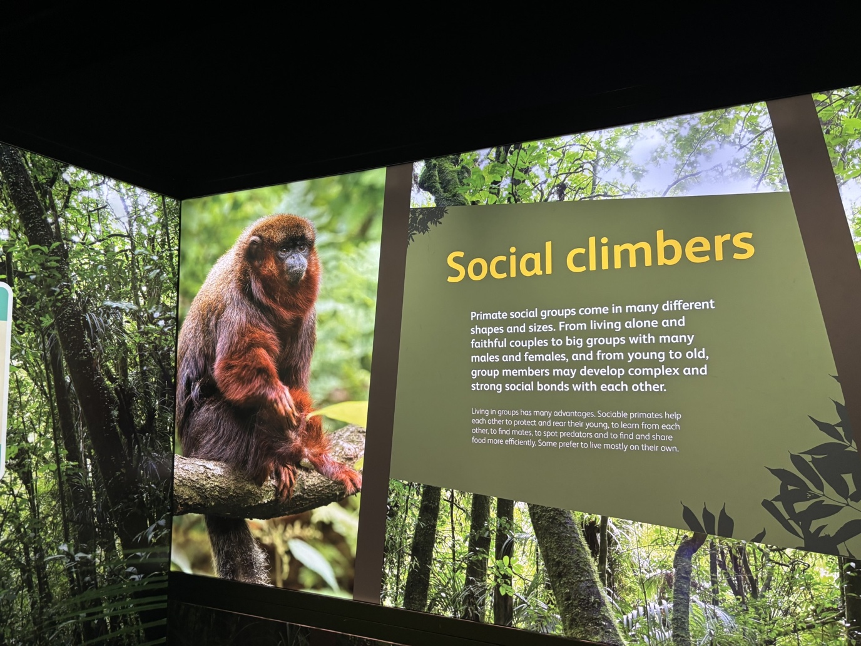

An Uncertain Future
Film
There is a black wall indicating where visitors can watch the ‘Primates today film.
This is an area with low lighting and seating. This film does contain distressing topics and scenes.
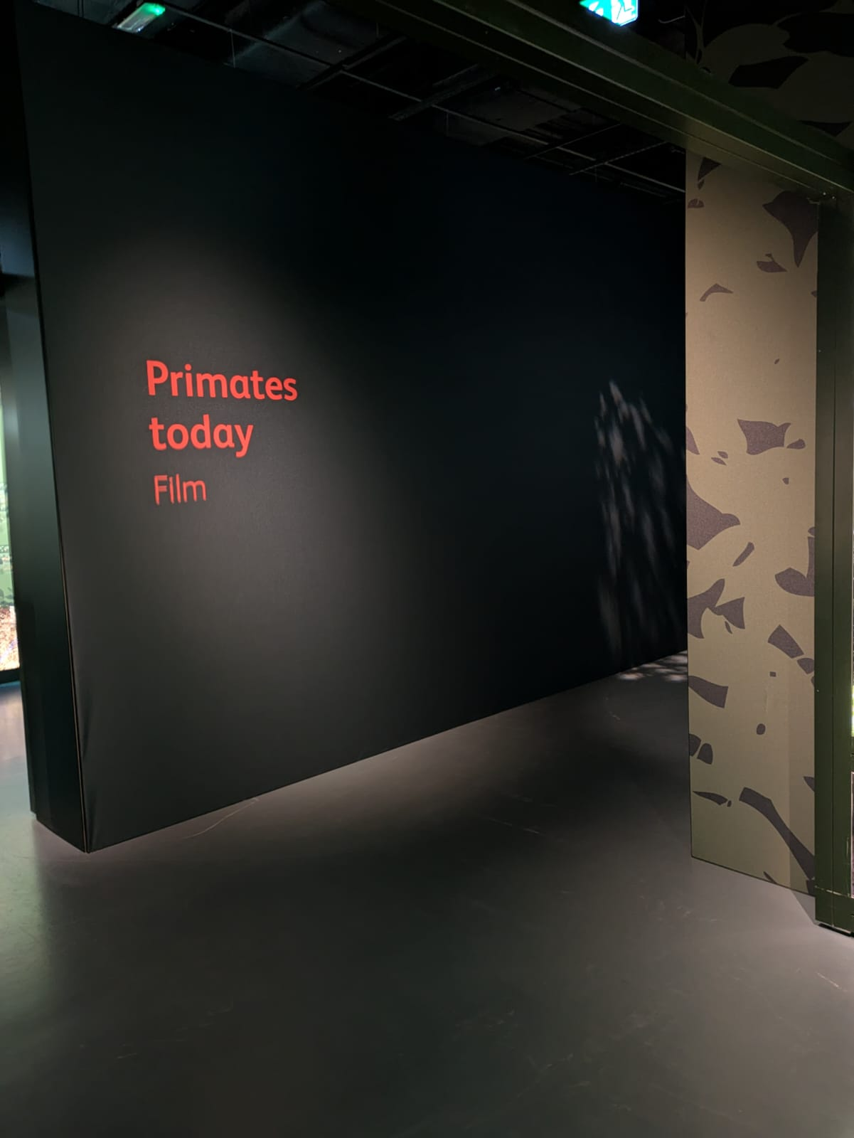

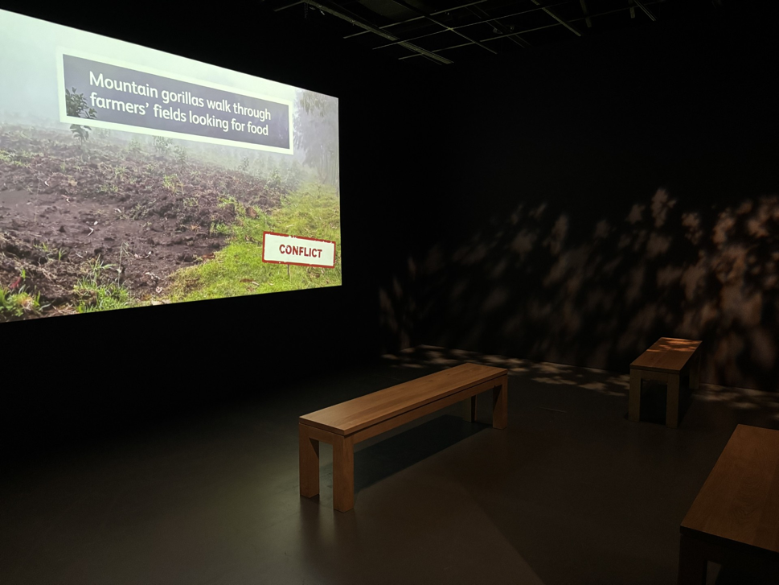
Interactive: third stamp station
This is the final stamp station. Visitors can stamp the last circle on their bookmarks with a lemur symbol
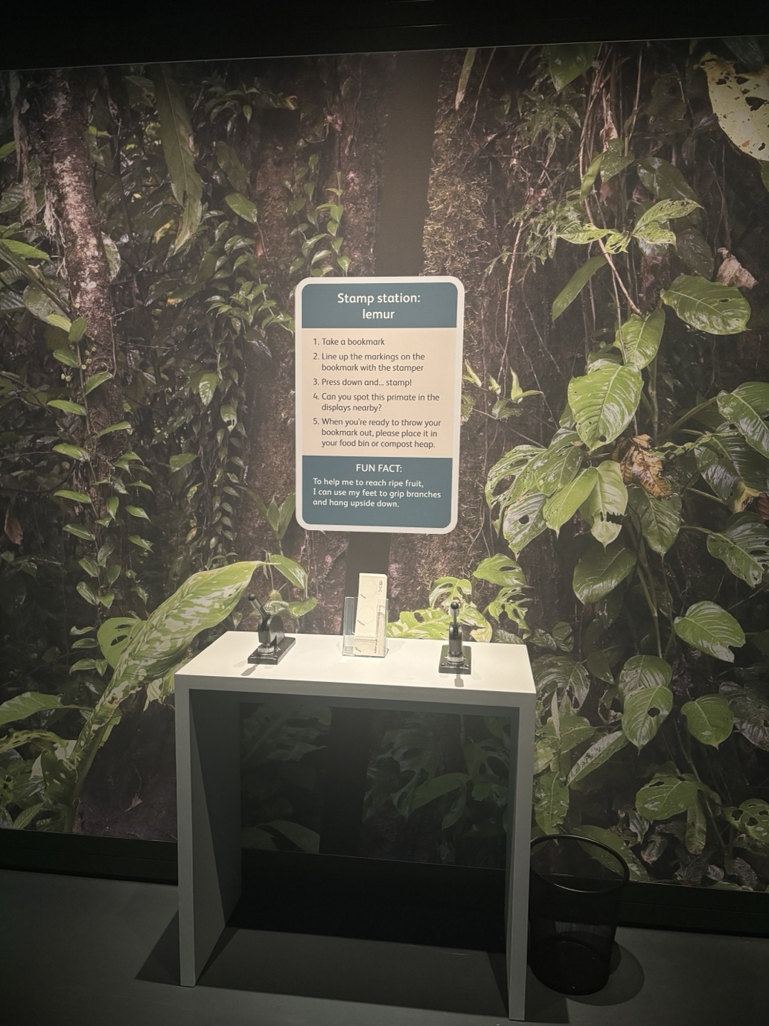

Interactive
After the film, there is an interactive screen with sound. The informative video tells visitors of current conservation efforts for primates around the world.
This video will give a warning and a countdown for when the audio will begin.

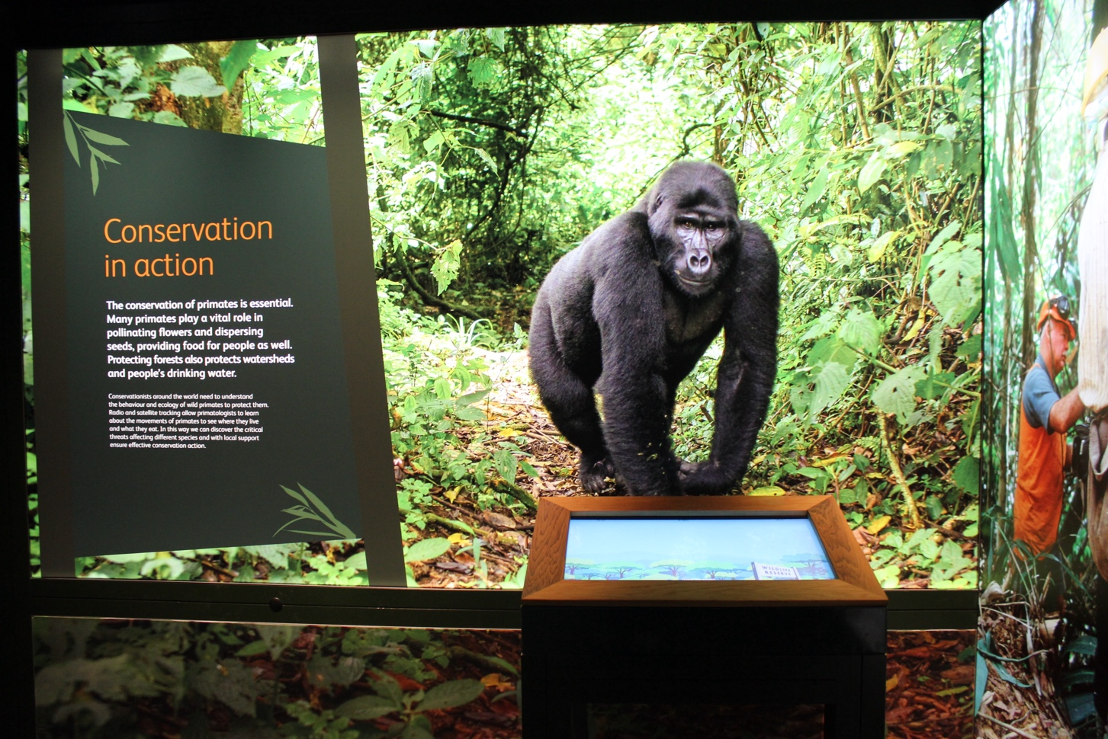

Interactive
This is an interactive screen where visitors can choose how they will help endangered primate species. This interactive does not have any sound.

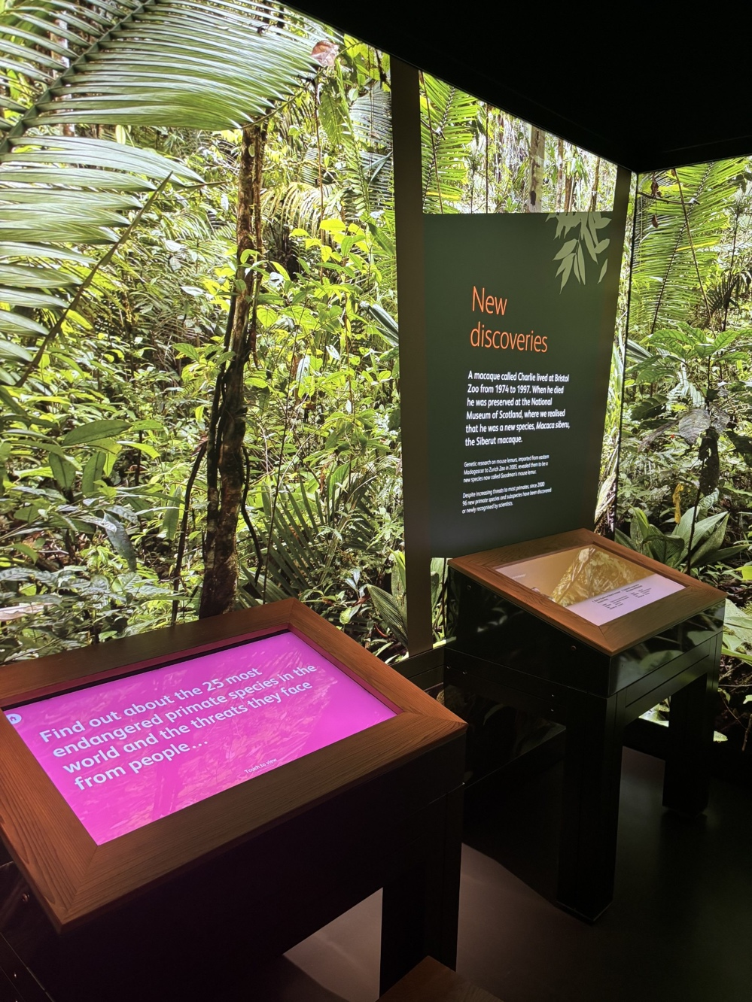

Exhibition exit and shop

You will exit the exhibition through this door.

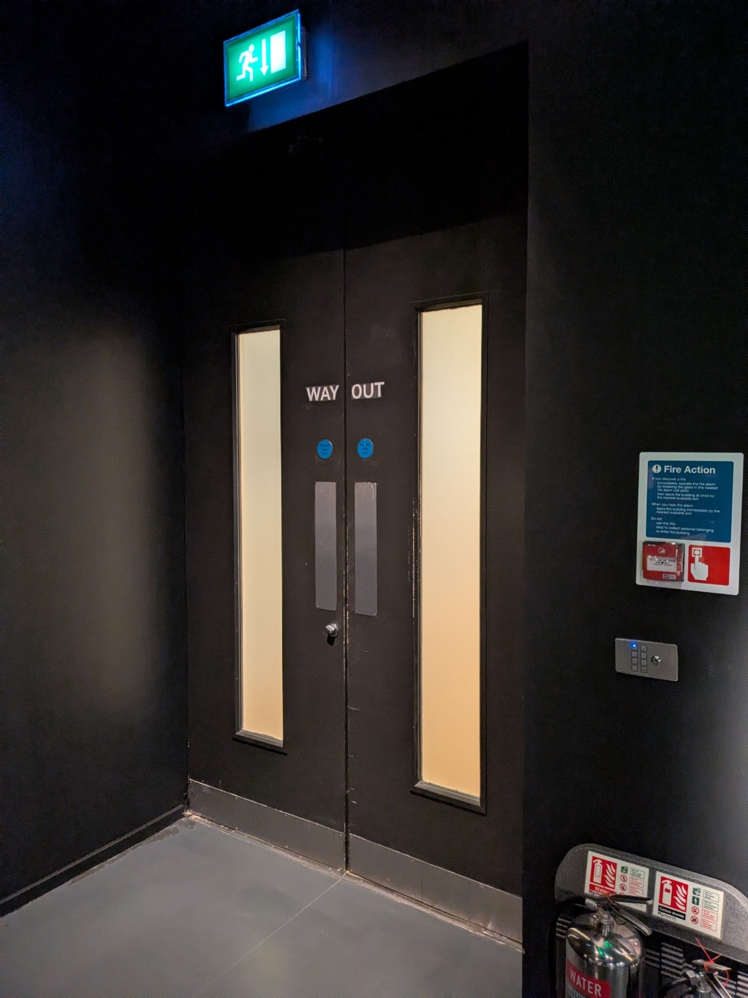

The Exhibition Shop is opposite the exit.
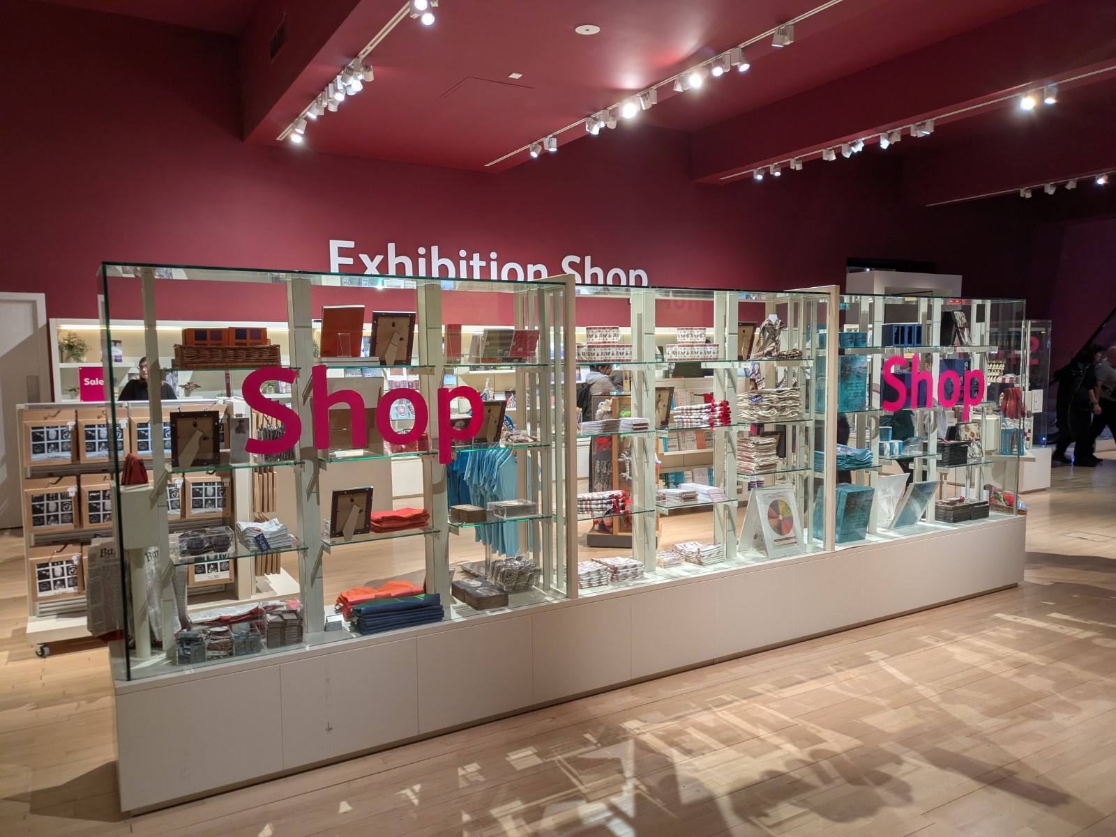

We hope you enjoy your visit.

Contact us
If you require any further information about the museum or the exhibition please use the following contact details:
Email: communities@nms.ac.uk
Call: 0300 123 6789 (Monday–Friday, 10:00–17:00)
Or visit our website www.nms.ac.uk

